Auxiliary Constructions

Definition
# Source: AI Source: Provided by: [Data Path: Persons Table -> ID Column: 1, Name_En Column: Motasem Essam] -> From: [ChatGPT] on [7/25/2026]
Auxiliary Constructions are additional geometric objects—such as points, line segments, rays, lines, circles, arcs, perpendiculars, parallels, or other figures—that are constructed temporarily to help solve a geometric problem or complete a geometric proof.
An auxiliary construction is usually not part of the original given figure. It is introduced because it creates a useful relationship that makes the desired result easier to establish.
$$\boxed{\text{Given Figure}→\text{Auxiliary Construction}→\text{Useful Relationship}→\text{Solution / Proof}}$$
Simple Definition
An auxiliary construction is an additional geometric object deliberately added to a figure to make a problem easier to solve or prove.

Fundamental Concept
# Source: AI Source: Provided by: [Data Path: Persons Table -> ID Column: 1, Name_En Column: Motasem Essam] -> From: [ChatGPT] on [7/25/2026]
Many geometry problems become difficult because the important relationship is not immediately visible in the original diagram.
An auxiliary construction changes the configuration without changing the original facts.
For example, if two points are difficult to compare directly, we might construct a segment connecting them:
$$\boxed{\text{Construct }AD}$$
The new segment may create:
- a triangle,
- congruent triangles,
- similar triangles,
- equal angles,
- equal lengths,
- parallel lines,
- perpendicular lines,
- circles,
- or useful ratios.
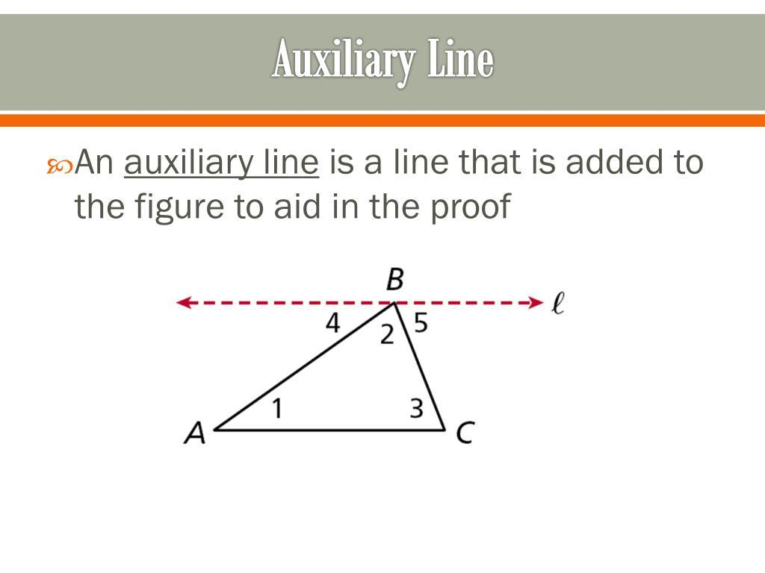
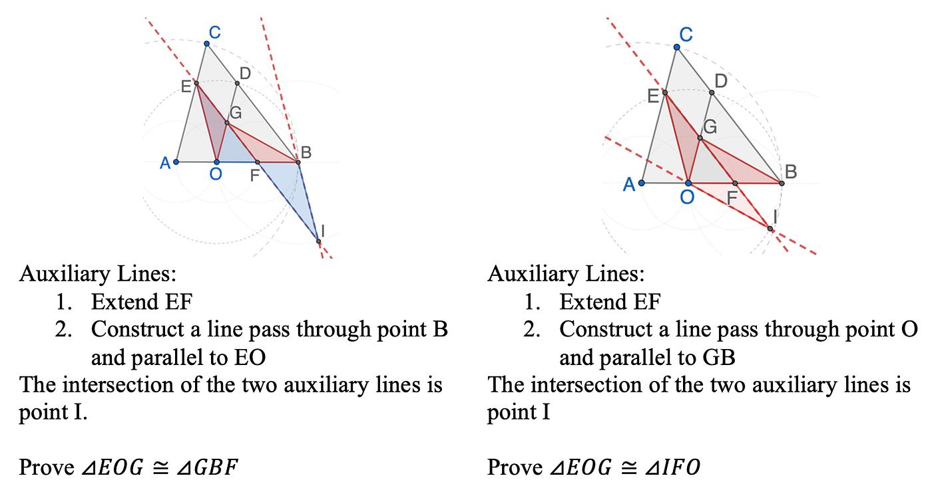
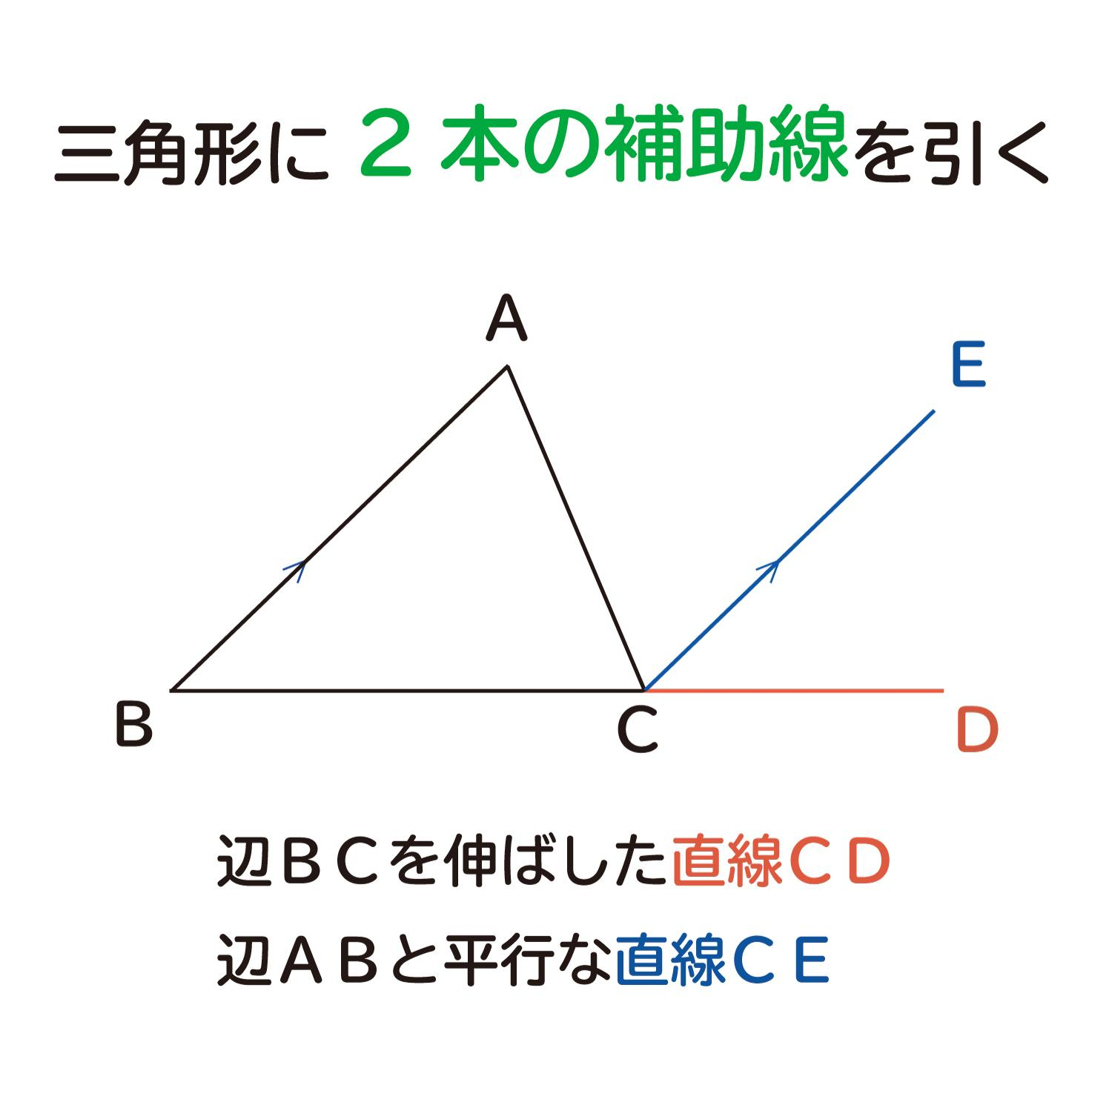
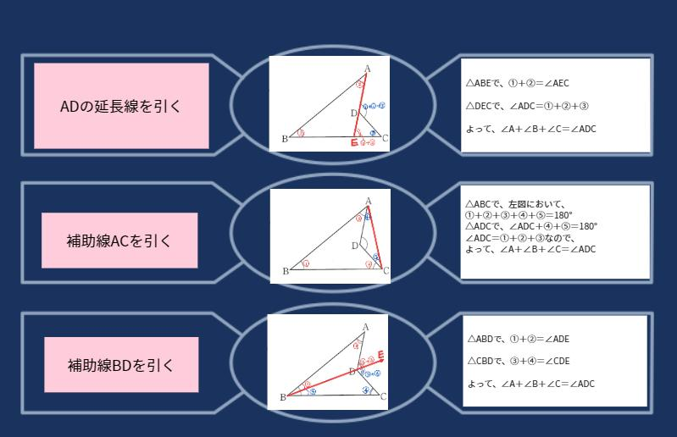

Main Purpose
# Source: AI Source: Provided by: [Data Path: Persons Table -> ID Column: 1, Name_En Column: Motasem Essam] -> From: [ChatGPT] on [7/25/2026]
Auxiliary constructions are mainly used to create relationships that are easier to reason about than the original configuration.
Common purposes include:
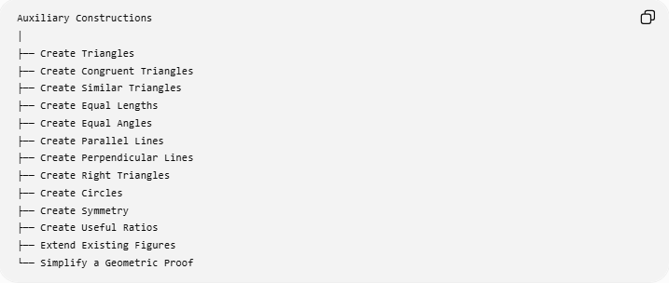
Auxiliary Constructions
│
├── Create Triangles
├── Create Congruent Triangles
├── Create Similar Triangles
├── Create Equal Lengths
├── Create Equal Angles
├── Create Parallel Lines
├── Create Perpendicular Lines
├── Create Right Triangles
├── Create Circles
├── Create Symmetry
├── Create Useful Ratios
├── Extend Existing Figures
└── Simplify a Geometric Proof

Adding an Auxiliary Segment
# Source: AI Source: Provided by: [Data Path: Persons Table -> ID Column: 1, Name_En Column: Motasem Essam] -> From: [ChatGPT] on [7/25/2026]
One of the most common auxiliary constructions is simply drawing an additional segment.
Suppose a quadrilateral $ABCD$is given.
We can construct diagonal $AC$:
$$\boxed{AC}$$
This divides the quadrilateral into two triangles:
$$△ABC$$
and
$$△ACD.$$
The original quadrilateral problem can therefore become two triangle problems.
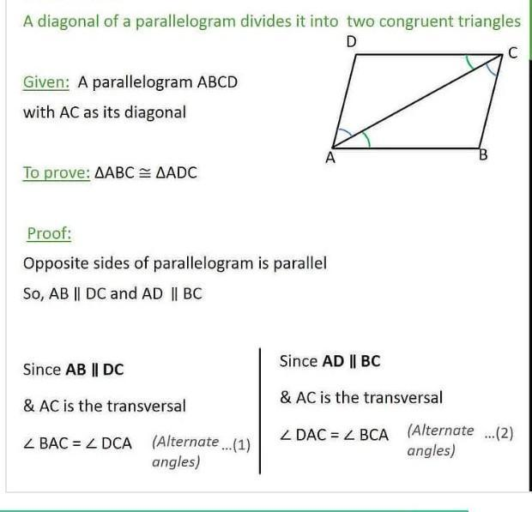
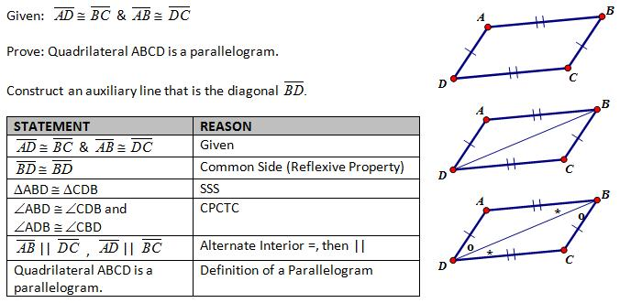
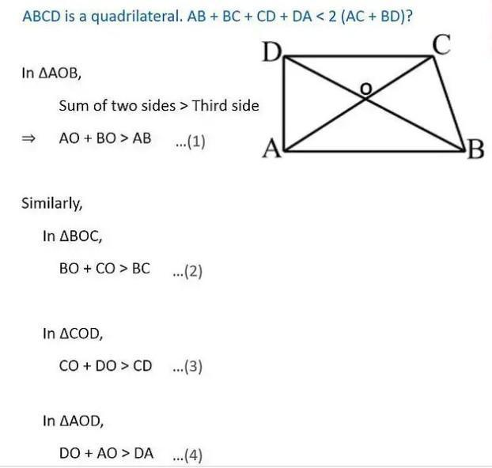
Example
To prove properties of a parallelogram, constructing diagonal $AC$can create:
$$△ABC$$
and:
$$△CDA.$$
These triangles can then be compared using congruence.

Constructing a Diagonal
# Source: AI Source: Provided by: [Data Path: Persons Table -> ID Column: 1, Name_En Column: Motasem Essam] -> From: [ChatGPT] on [7/25/2026]
A diagonal can be an auxiliary construction when it is added to a polygon specifically to facilitate a proof or solution.
For example:
$$\boxed{\text{Quadrilateral}→\text{Construct diagonal}→\text{Two triangles}}$$
This is especially useful for:
- quadrilaterals,
- polygons,
- area problems,
- congruence proofs,
- angle problems.
Example
A parallelogram $ABCD$has diagonal $AC$.
The construction creates:
$$△ABC$$
and:
$$△CDA.$$
Since opposite sides of a parallelogram are equal:
$$AB=CD$$
and:
$$BC=AD,$$
while:
$$AC=AC.$$
Therefore:
$$\boxed{△ABC≅△CDA}$$
by SSS.
The auxiliary diagonal made the congruence relationship visible.

Constructing an Auxiliary Perpendicular
# Source: AI Source: Provided by: [Data Path: Persons Table -> ID Column: 1, Name_En Column: Motasem Essam] -> From: [ChatGPT] on [7/25/2026]
A perpendicular line can be added to create a right triangle.
For example, from point $P$, construct:
$$PH⊥AB.$$
Then:
$$\boxed{∠PHA={90}^{∘}}$$
and:
$$\boxed{∠PHB={90}^{∘}}.$$
This can introduce:
- right triangles,
- perpendicular distances,
- Pythagorean theorem,
- altitude relationships,
- area formulas.
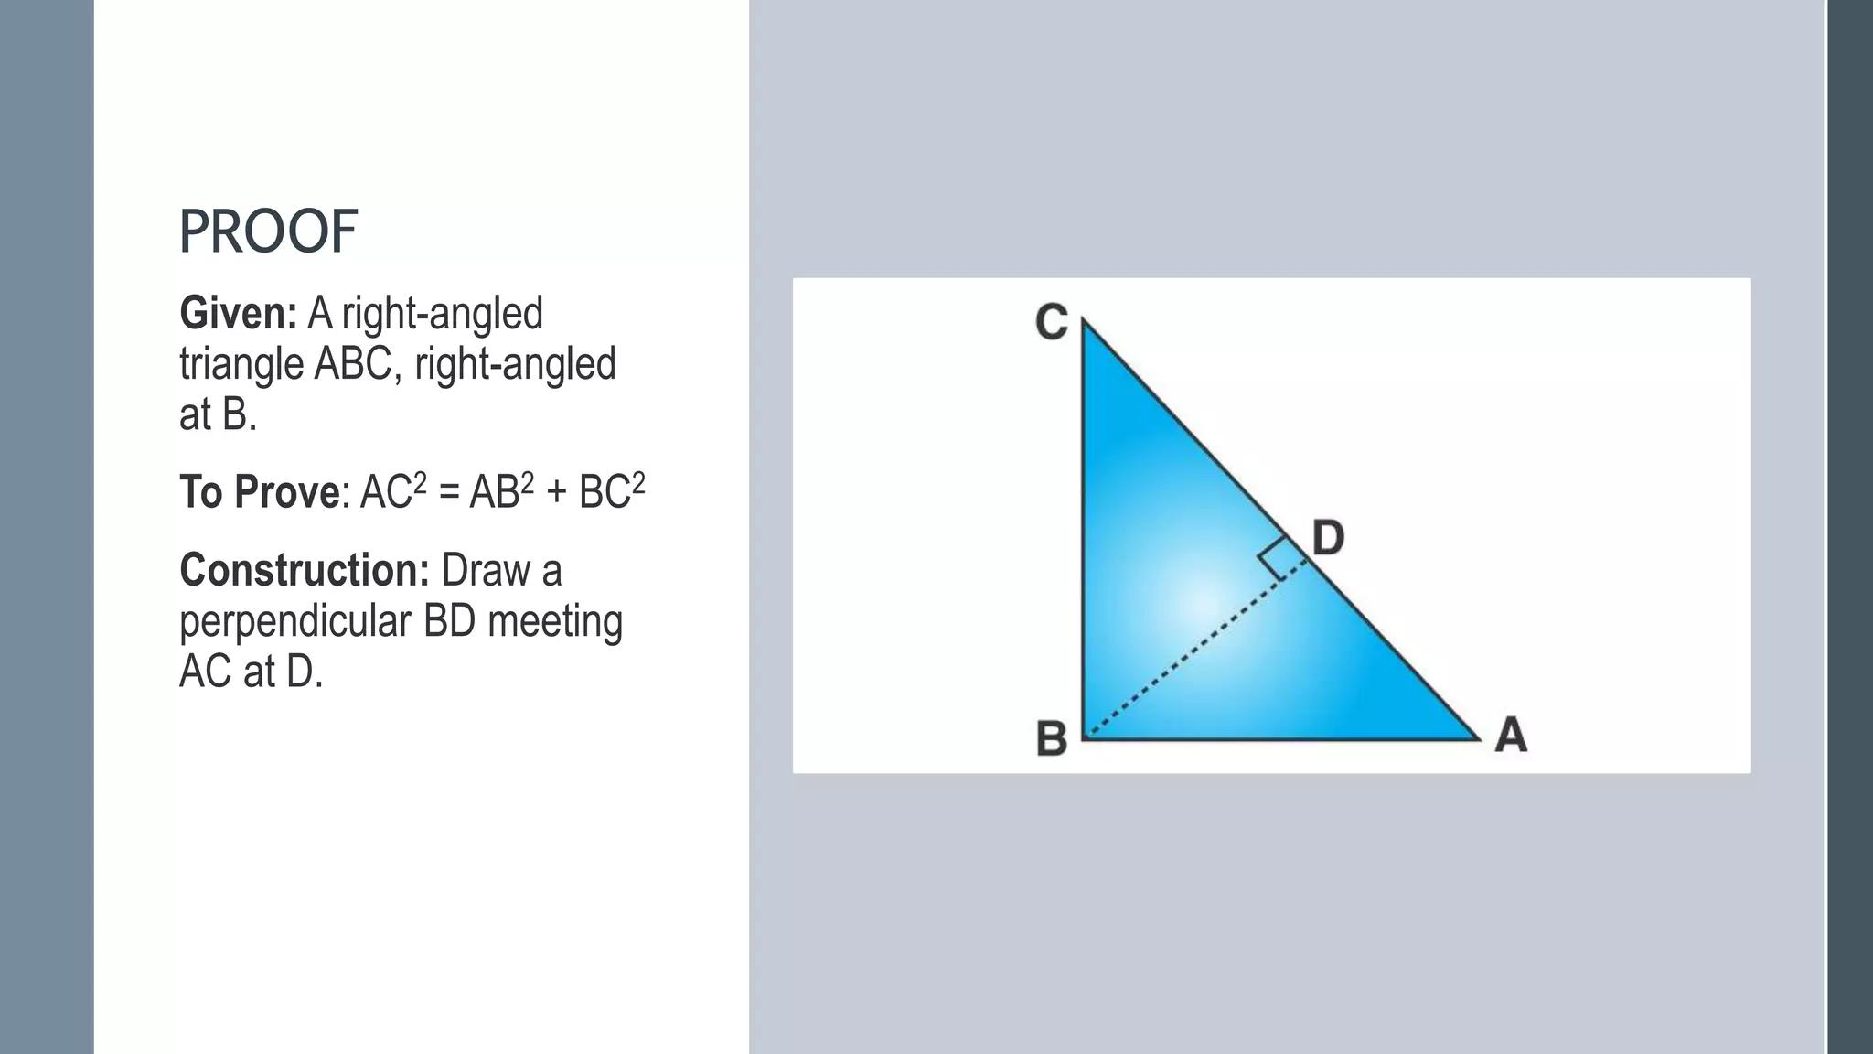
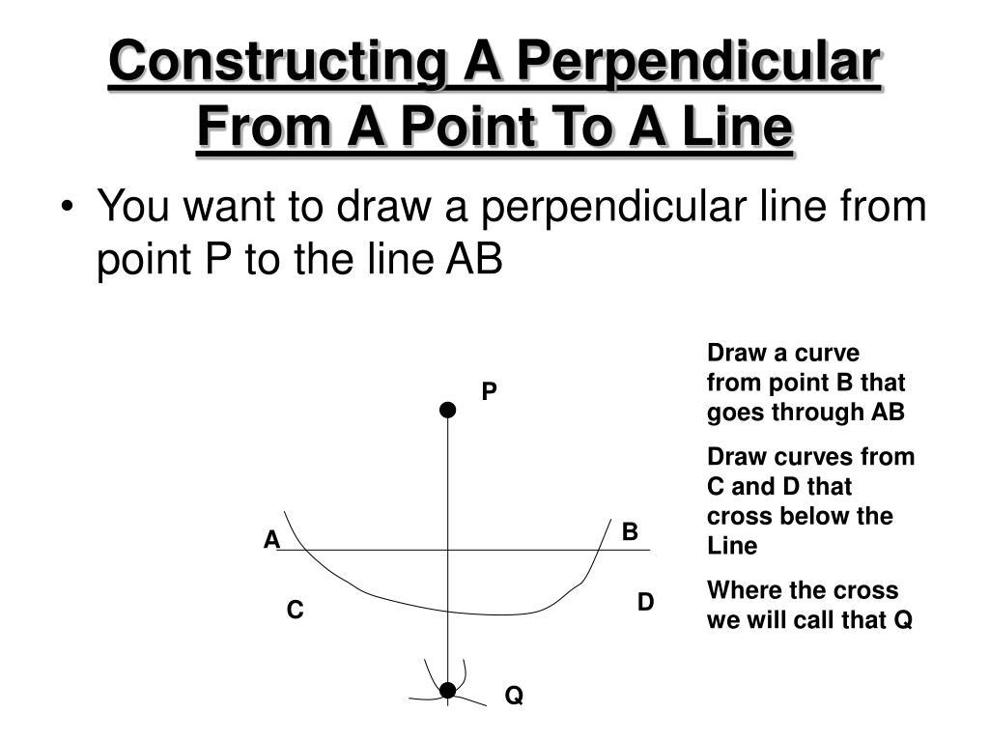
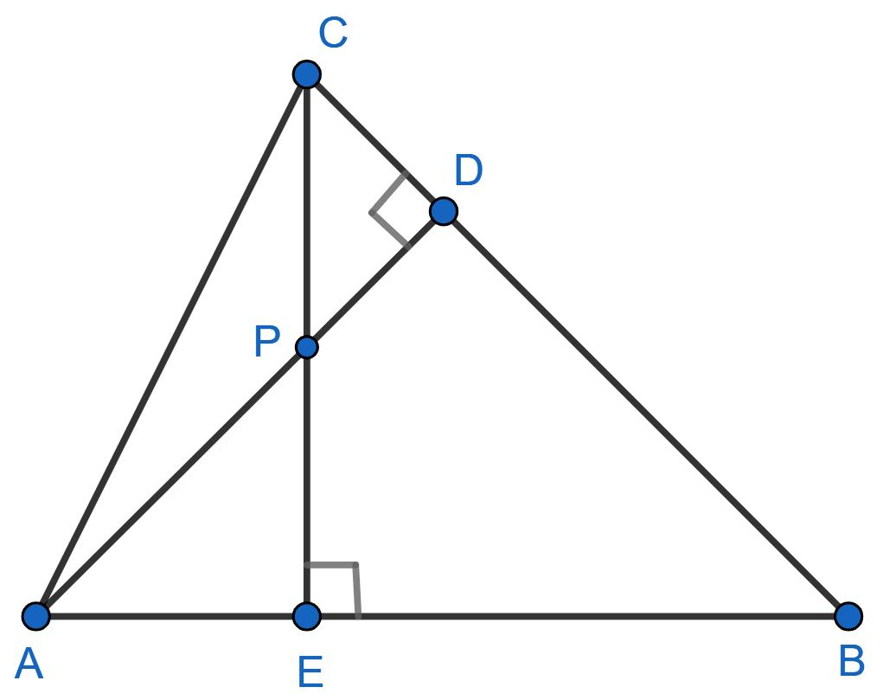
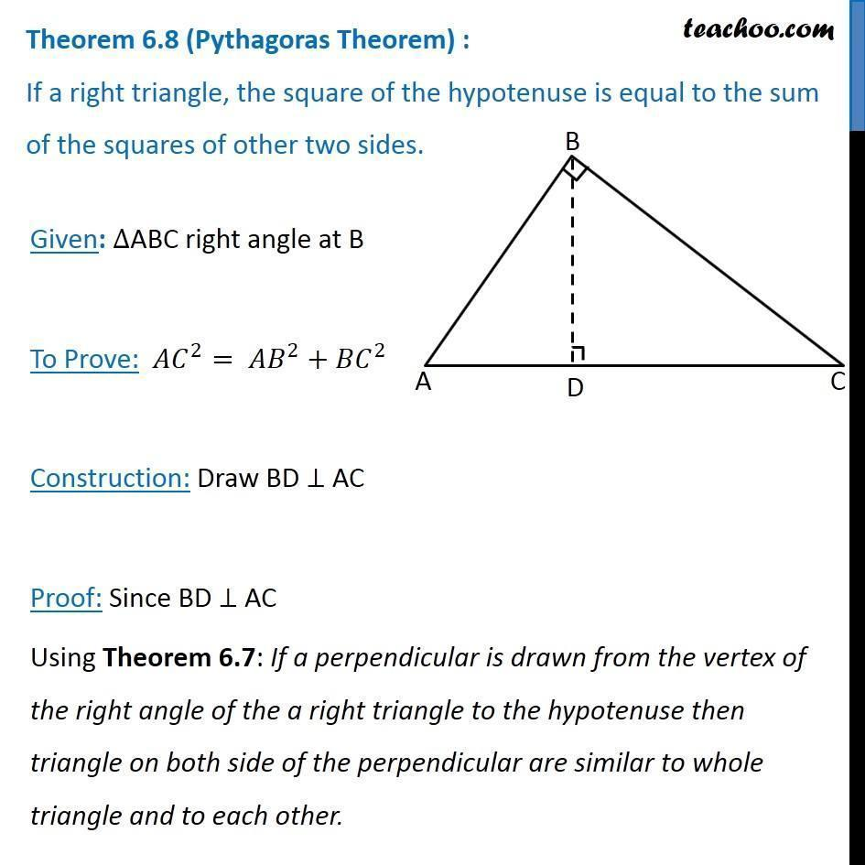
Example
If $P$is outside a line $AB$, constructing $PH⊥AB$gives the shortest distance from $P$to $AB$:
$$\boxed{d\left(P , AB\right)=PH}.$$

Constructing an Auxiliary Altitude
# Source: AI Source: Provided by: [Data Path: Persons Table -> ID Column: 1, Name_En Column: Motasem Essam] -> From: [ChatGPT] on [7/25/2026]
An altitude can be constructed to create right triangles.
Given:
$$△ABC,$$
construct:
$$AD⊥BC.$$
Then $AD$is an altitude.
The triangle is divided into:
$$△ABD$$
and:
$$△ACD.$$
Each is a right triangle.
This can be useful for:
$$a^{2}+b^{2}=c^{2}$$
and:
$$A=\frac{1}{2}bh.$$
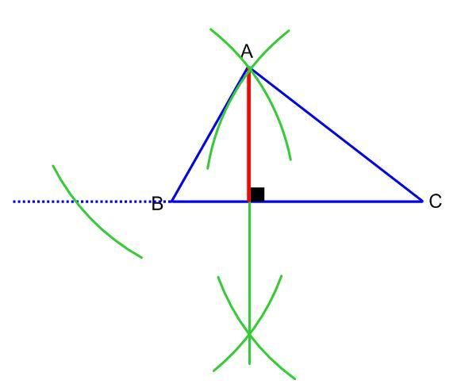
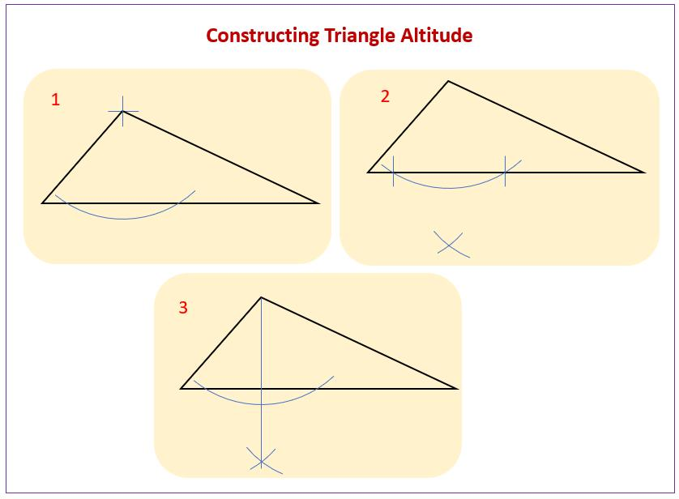
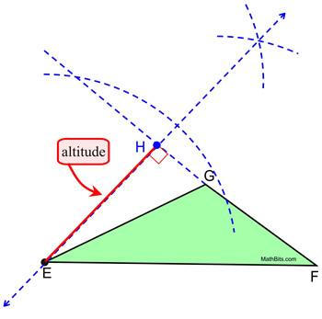
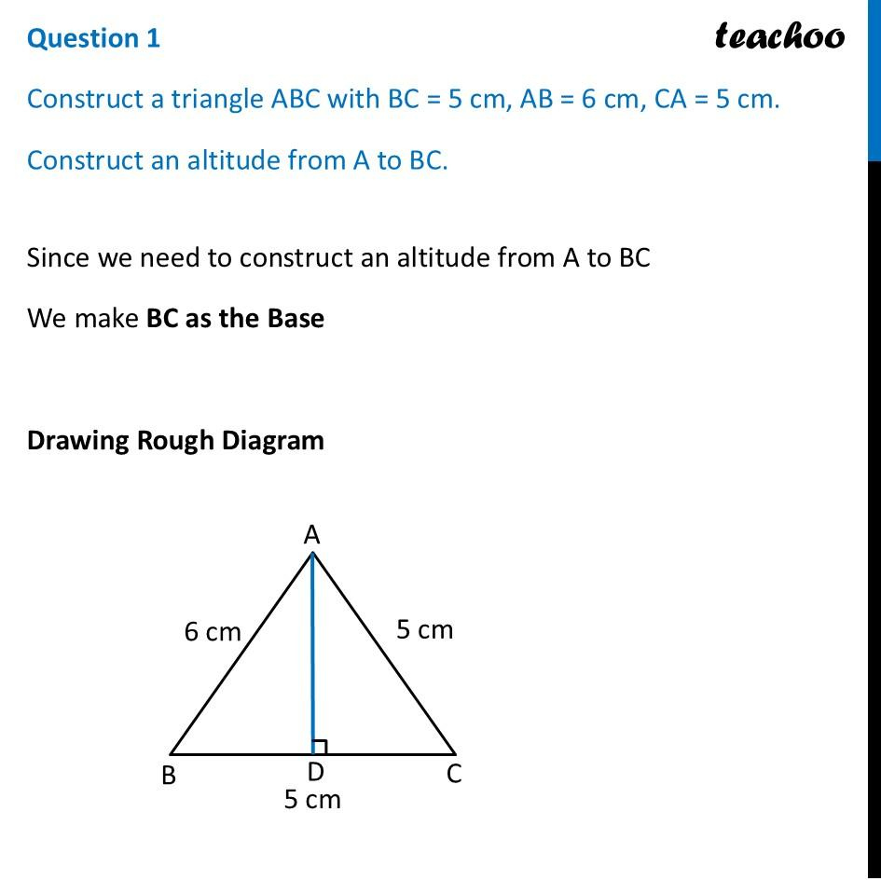
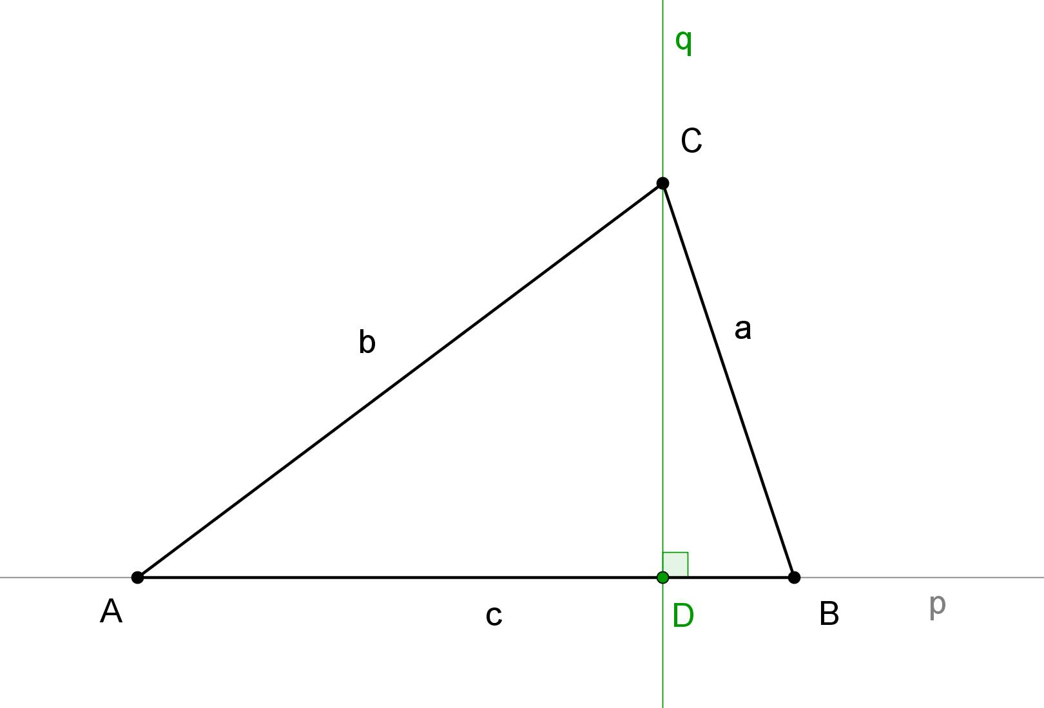

Constructing an Auxiliary Parallel Line
# Source: AI Source: Provided by: [Data Path: Persons Table -> ID Column: 1, Name_En Column: Motasem Essam] -> From: [ChatGPT] on [7/25/2026]
A parallel line can be introduced to create equal angles.
For example, through $A$, construct:
$$l∥BC.$$
A transversal can then produce relationships such as:
$$\boxed{∠1=∠2}$$
through corresponding or alternate interior angles.
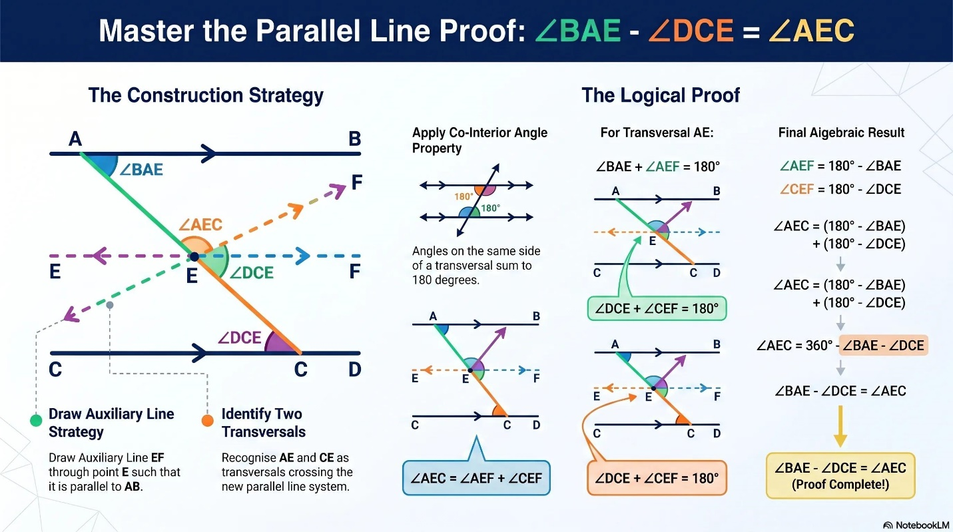
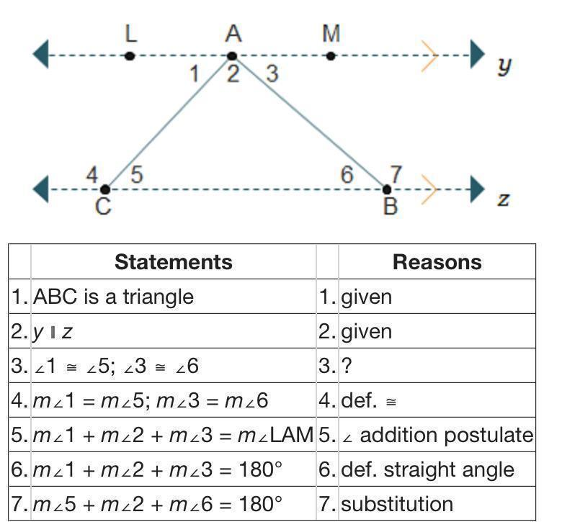
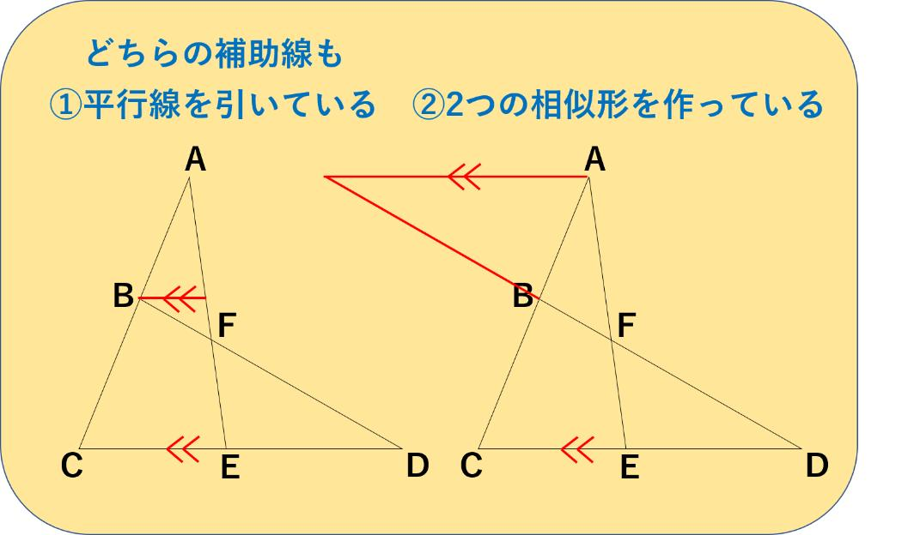
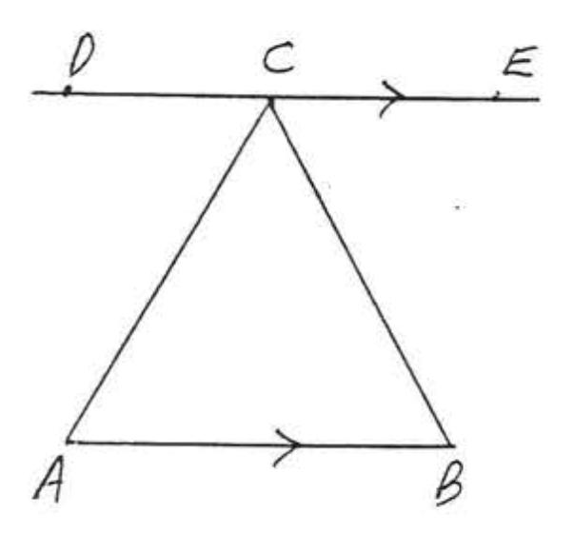
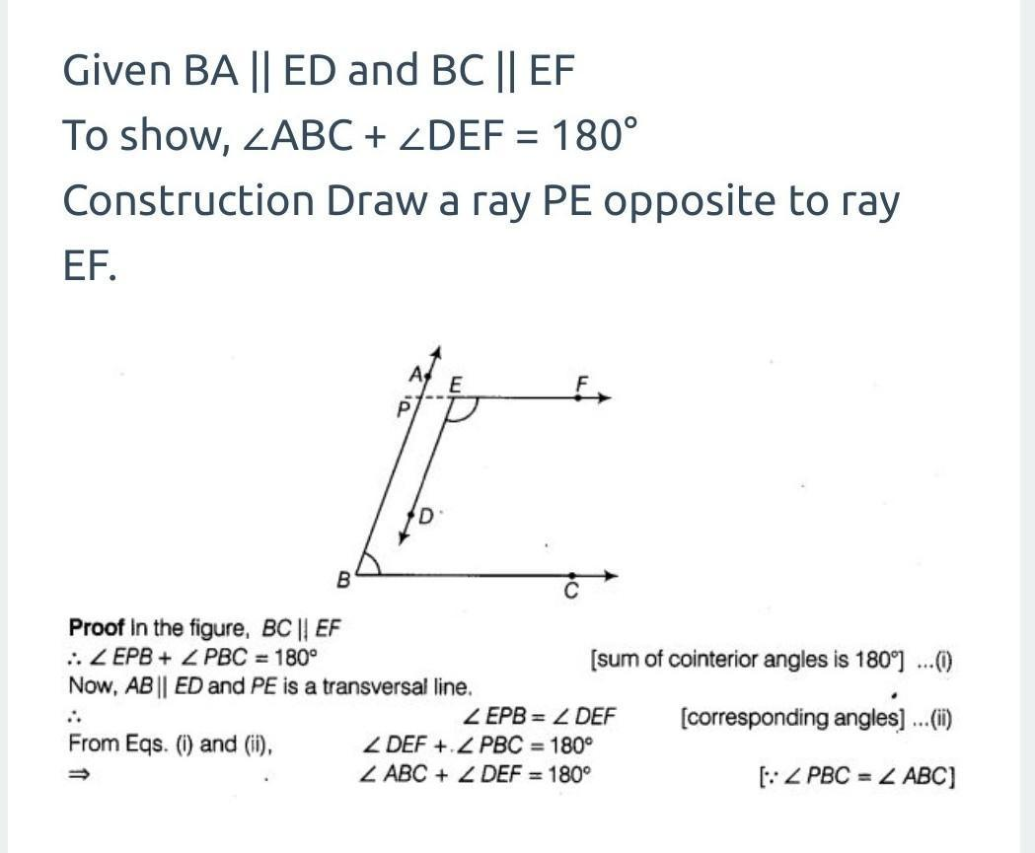
Example
In a triangle, a parallel line can create a smaller triangle similar to the original triangle.
$$DE∥BC$$
gives:
$$△ADE∼△ABC.$$
Therefore:
$$\frac{AD}{AB}=\frac{AE}{AC}=\frac{DE}{BC}.$$
Thus, one auxiliary parallel line can introduce angle equality and ratio equality.

Constructing an Auxiliary Circle
# Source: AI Source: Provided by: [Data Path: Persons Table -> ID Column: 1, Name_En Column: Motasem Essam] -> From: [ChatGPT] on [7/25/2026]
A circle can be added when a problem involves:
- equal distances,
- equal chords,
- tangent relationships,
- cyclic quadrilaterals,
- angles,
- circumcenters,
- incircles.
For example, if several points must be shown to have equal distance from $O$, construct a circle centered at $O$.
$$OA=OB=OC=r.$$
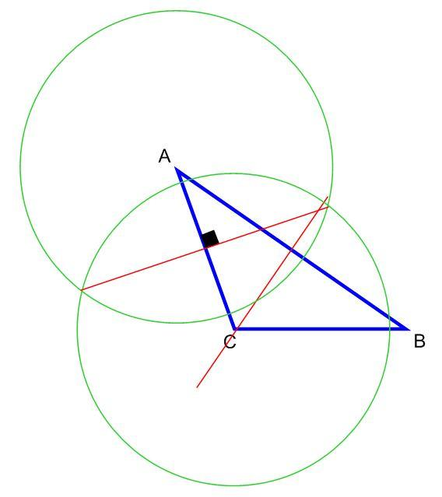
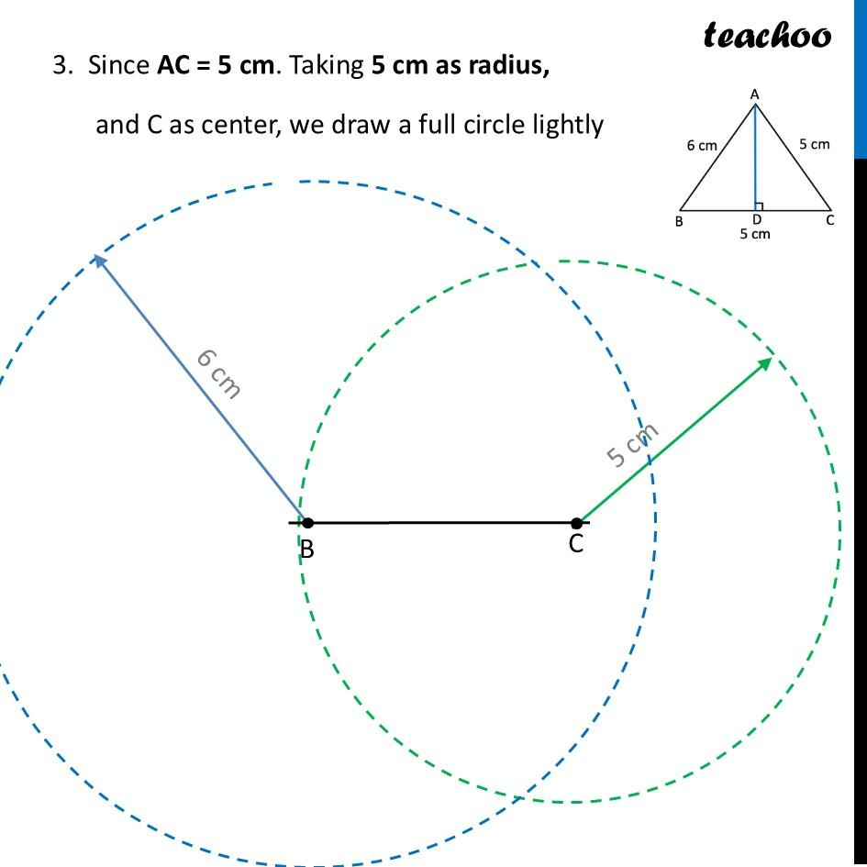
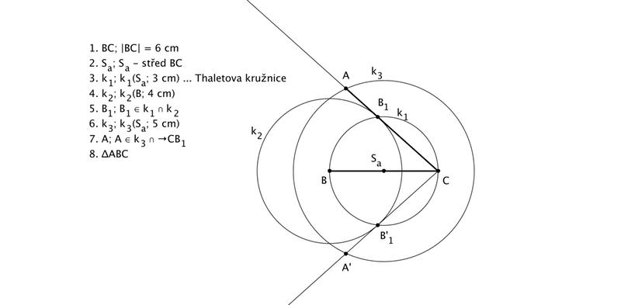
Example
Suppose:
$$OA=OB.$$
Construct the circle centered at $O$with radius $OA$.
Then both $A$and $B$lie on the same circle.
This converts a distance relationship into a circle relationship.

Constructing an Auxiliary Arc
# Source: AI Source: Provided by: [Data Path: Persons Table -> ID Column: 1, Name_En Column: Motasem Essam] -> From: [ChatGPT] on [7/25/2026]
An arc can be added to create equal distances or equal angles.
For example, when constructing an angle bisector, an arc intersects the two sides of the angle.
If the intersection points are $B$and $C$, then the construction gives:
$$AB=AC.$$
Additional equal-radius arcs can then create another equality.
This is a fundamental example of how a construction can deliberately introduce equality into a diagram.

Extending a Side
# Source: AI Source: Provided by: [Data Path: Persons Table -> ID Column: 1, Name_En Column: Motasem Essam] -> From: [ChatGPT] on [7/25/2026]
Sometimes an existing side is extended beyond a vertex.
For example:
$$A-B-C$$
can be extended to:
$$A-B-C-D.$$
This can create:
- exterior angles,
- linear pairs,
- supplementary angles,
- similar triangles,
- ratios,
- applications of Menelaus' theorem.
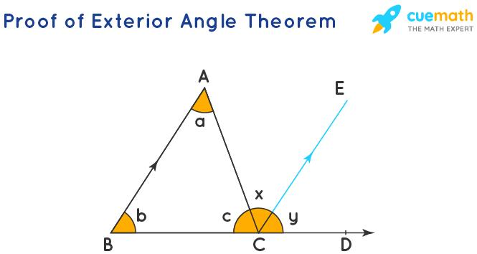
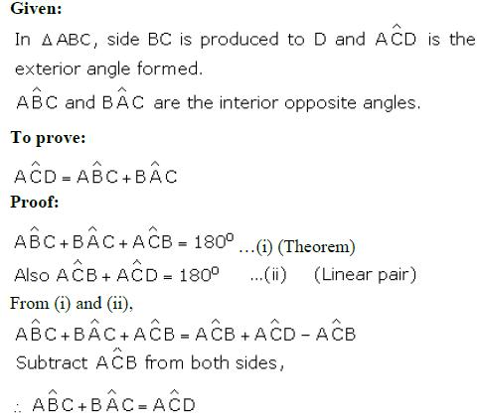
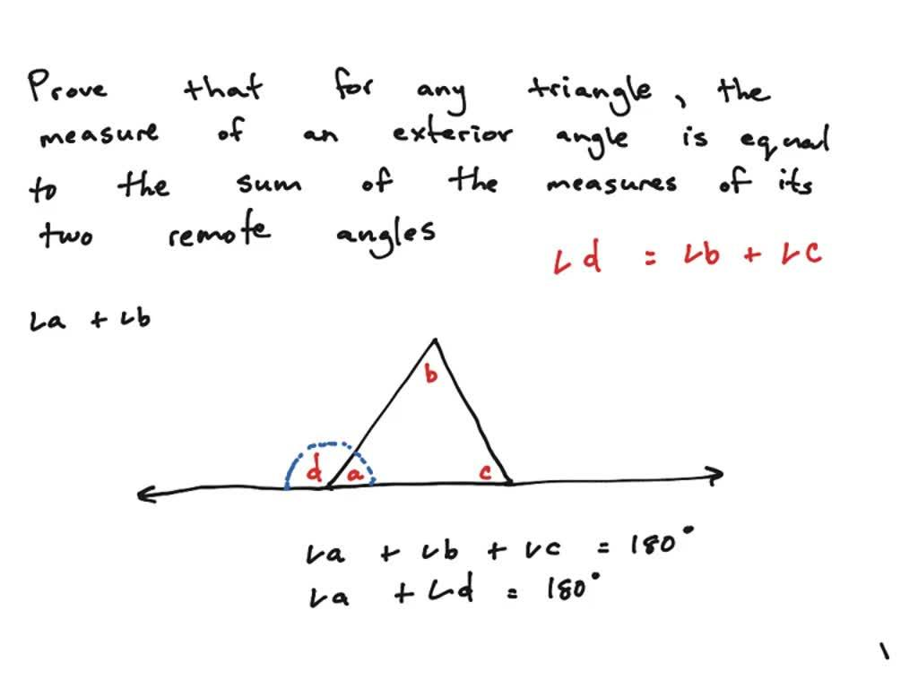
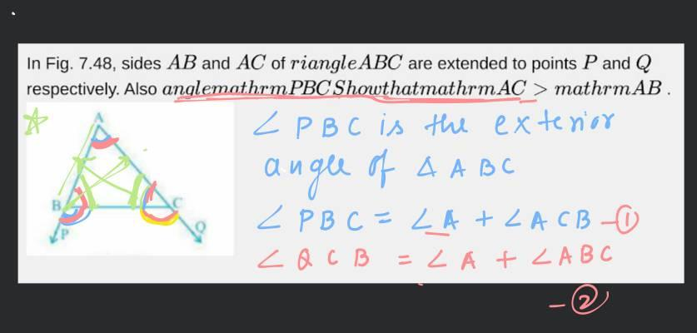
Example
If $BC$is extended to $D$, then:
$$∠ACD+∠ACB={180}^{∘}.$$
Thus the construction creates a linear-pair relationship.

Constructing an Auxiliary Angle Bisector
# Source: AI Source: Provided by: [Data Path: Persons Table -> ID Column: 1, Name_En Column: Motasem Essam] -> From: [ChatGPT] on [7/25/2026]
An angle bisector may be constructed when equal angles are needed.
Given:
$$∠BAC,$$
construct:
$$AD$$
as its angle bisector.
Then:
$$\boxed{∠BAD=∠DAC}$$
This can lead to:
- congruent triangles,
- angle relationships,
- the incenter,
- proportional side relationships.
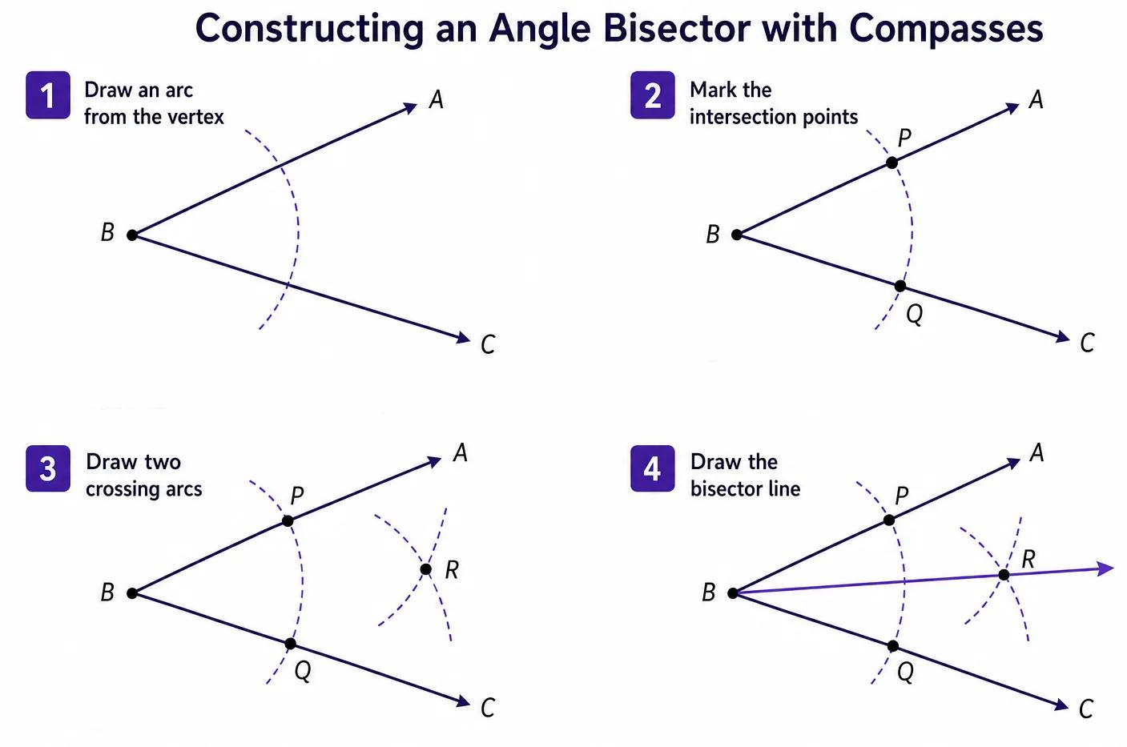
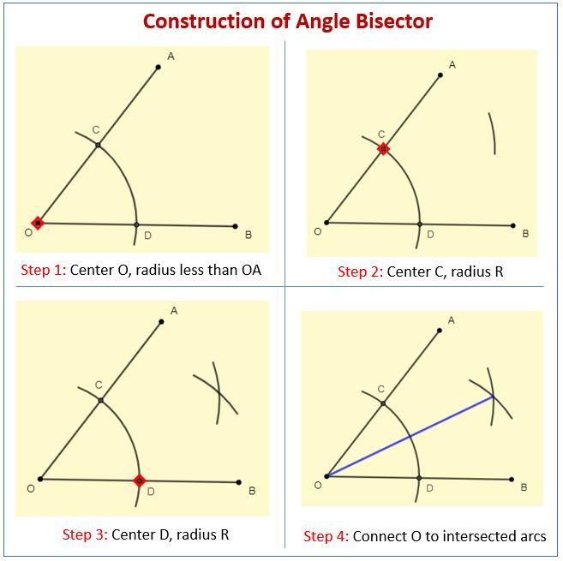
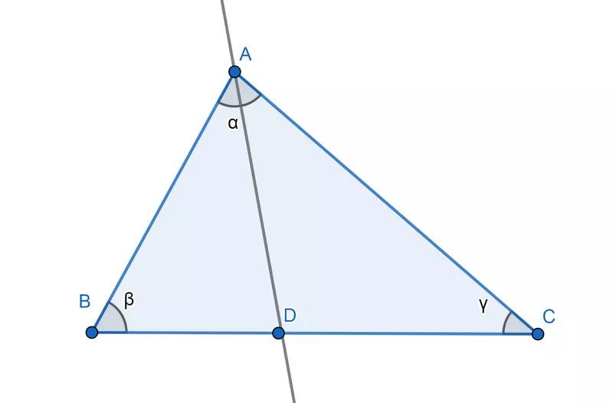

Constructing an Auxiliary Perpendicular Bisector
# Source: AI Source: Provided by: [Data Path: Persons Table -> ID Column: 1, Name_En Column: Motasem Essam] -> From: [ChatGPT] on [7/25/2026]
A perpendicular bisector can be added to introduce an equal-distance relationship.
For segment $AB$, construct its perpendicular bisector.
For a point $P$on that bisector:
$$\boxed{PA=PB}.$$
This can transform a geometric problem into an equal-distance problem.
It is particularly useful for:
- circumcenters,
- loci,
- circles,
- perpendicular-distance arguments,
- congruence proofs.

Constructing an Auxiliary Isosceles Triangle
# Source: AI Source: Provided by: [Data Path: Persons Table -> ID Column: 1, Name_En Column: Motasem Essam] -> From: [ChatGPT] on [7/25/2026]
Sometimes an auxiliary segment is deliberately constructed so that two lengths become equal.
For example, construct $AD$such that:
$$AD=AB.$$
Then:
$$△ABD$$
is isosceles.
Therefore:
$$\boxed{∠ABD=∠BDA}.$$
This can create equal angles that were not present in the original figure.

Constructing an Auxiliary Equilateral Triangle
# Source: AI Source: Provided by: [Data Path: Persons Table -> ID Column: 1, Name_En Column: Motasem Essam] -> From: [ChatGPT] on [7/25/2026]
An equilateral triangle can be constructed to introduce several equal lengths:
$$\boxed{AB=BC=CA}.$$
It also introduces:
$$\boxed{∠A=∠B=∠C={60}^{∘}}$$
This can be useful when solving problems involving:
- ${60}^{∘}$angles,
- rotations,
- equilateral structures,
- length relationships,
- transformations.
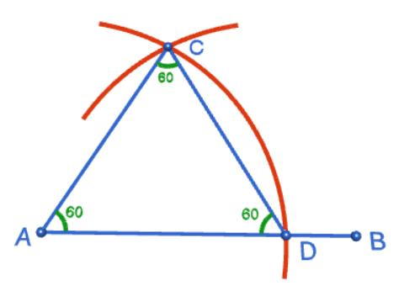
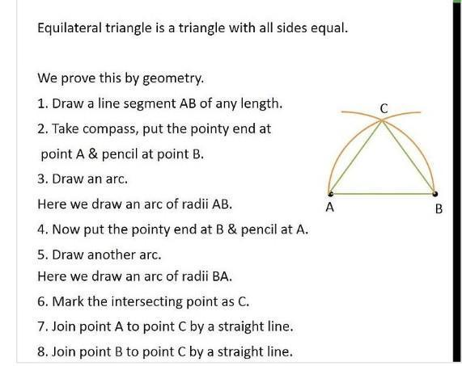
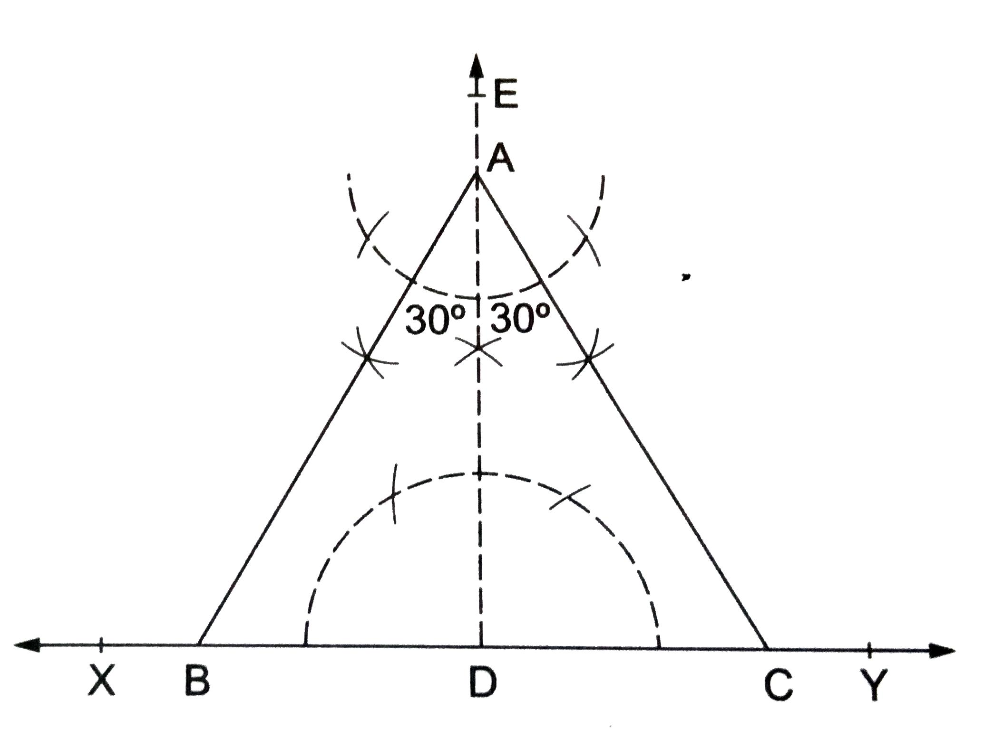
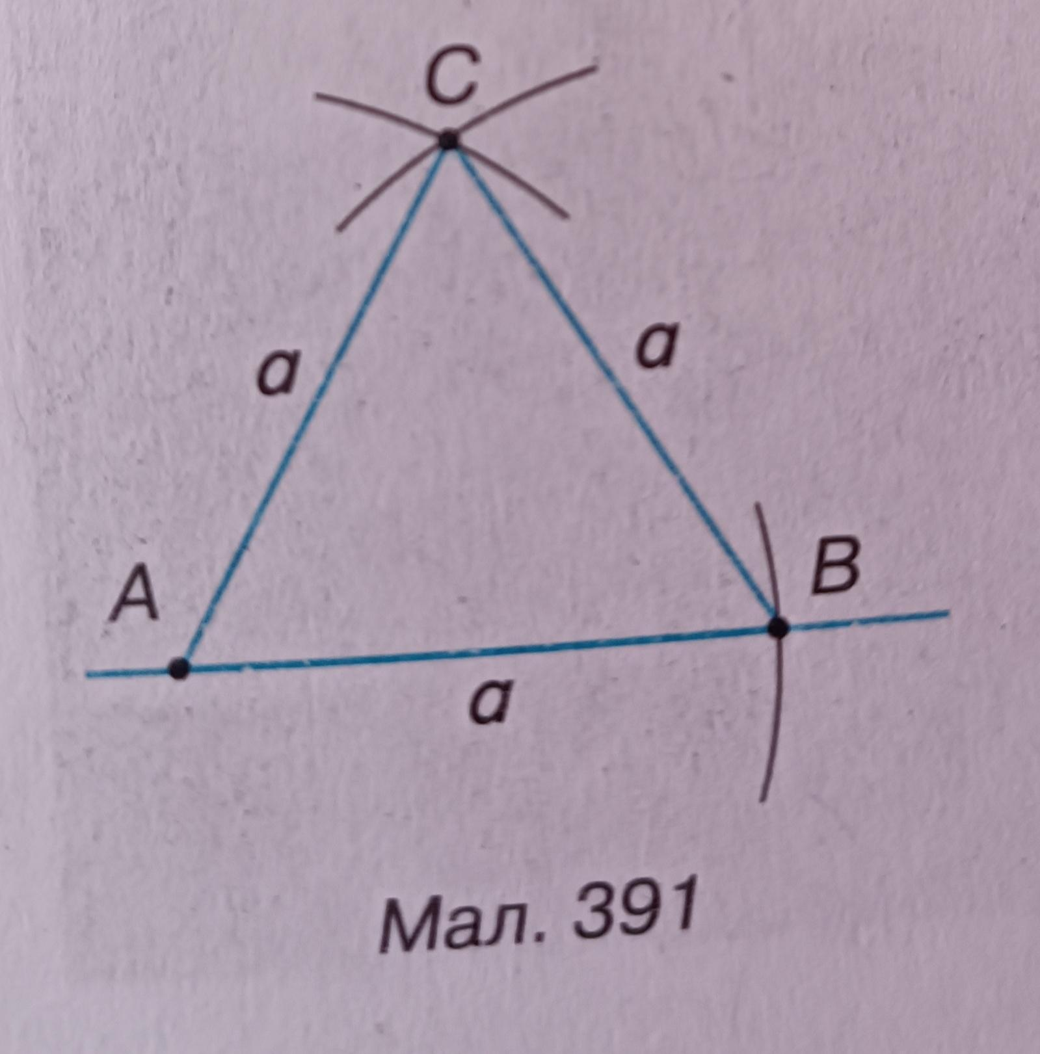

Constructing an Auxiliary Rectangle
# Source: AI Source: Provided by: [Data Path: Persons Table -> ID Column: 1, Name_En Column: Motasem Essam] -> From: [ChatGPT] on [7/25/2026]
A rectangle may sometimes be constructed around or inside a figure to create right angles and parallel lines.
A rectangle provides:
$$\boxed{\text{four right angles}}$$
and:
$$\boxed{\text{opposite sides parallel}}.$$
This can simplify area or length problems.
For example, an irregular region can sometimes be divided into rectangles and triangles.

Constructing an Auxiliary Triangle
# Source: AI Source: Provided by: [Data Path: Persons Table -> ID Column: 1, Name_En Column: Motasem Essam] -> From: [ChatGPT] on [7/25/2026]
One of the most powerful auxiliary constructions is creating a triangle where none was immediately useful.
For example, in a quadrilateral:
$$ABCD$$
construct diagonal:
$$AC.$$
Then:
$$ABCD→△ABC+△ACD.$$
This allows triangle-specific tools to be used:
- SSS,
- SAS,
- ASA,
- AAS,
- similarity,
- angle sum,
- Pythagorean theorem,
- trigonometry,
- Ceva,
- Menelaus,
- Stewart,
- Apollonius.

Constructing an Auxiliary Congruent Segment
# Source: AI Source: Provided by: [Data Path: Persons Table -> ID Column: 1, Name_En Column: Motasem Essam] -> From: [ChatGPT] on [7/25/2026]
A segment can be deliberately copied to create a useful equality.
For example, construct $DE$such that:
$$\boxed{DE=AB}.$$
Now a triangle containing $DE$may have two equal sides.
This can create an isosceles triangle or satisfy an SSS/SAS congruence condition.
The general idea is:
$$\boxed{\text{Copy a length}→\text{Create equality}→\text{Create useful theorem}}$$

Constructing an Auxiliary Congruent Figure
# Source: AI Source: Provided by: [Data Path: Persons Table -> ID Column: 1, Name_En Column: Motasem Essam] -> From: [ChatGPT] on [7/25/2026]
An entire figure can sometimes be copied, reflected, rotated, or translated.
For example:
$$F^{'}≅F.$$
This can create corresponding equal:
$$\text{lengths}$$
and:
$$\text{angles}.$$
An auxiliary congruent figure may make symmetry or a hidden relationship easier to see.

Constructing an Auxiliary Similar Figure
# Source: AI Source: Provided by: [Data Path: Persons Table -> ID Column: 1, Name_En Column: Motasem Essam] -> From: [ChatGPT] on [7/25/2026]
A smaller or larger copy can be introduced to create proportional relationships.
For example:
$$△ADE∼△ABC.$$
Then:
$$\frac{AD}{AB}=\frac{AE}{AC}=\frac{DE}{BC}.$$
This is useful when a problem contains:
- proportional lengths,
- parallel lines,
- scale factors,
- inaccessible lengths,
- area ratios.

Constructing an Auxiliary Center
# Source: AI Source: Provided by: [Data Path: Persons Table -> ID Column: 1, Name_En Column: Motasem Essam] -> From: [ChatGPT] on [7/25/2026]
Special points can be constructed to reveal important relationships.
Examples:
Circumcenter
Construct perpendicular bisectors:
$$OA=OB=OC.$$
Incenter
Construct angle bisectors:
$$∠BAI=∠IAC.$$
and:
$$∠ABI=∠IBC.$$
Centroid
Construct medians.
If $G$is the centroid:
$$AG:GD=2:1.$$
Orthocenter
Construct altitudes.
Thus:
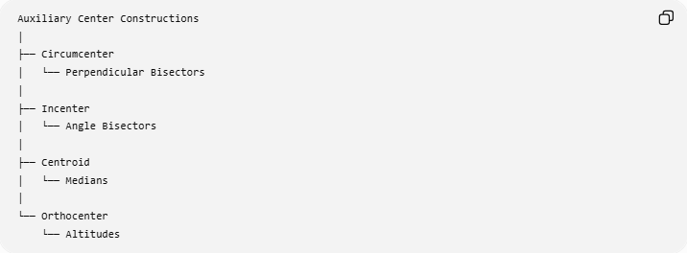
Auxiliary Center Constructions
│
├── Circumcenter
│ └── Perpendicular Bisectors
│
├── Incenter
│ └── Angle Bisectors
│
├── Centroid
│ └── Medians
│
└── Orthocenter
└── Altitudes
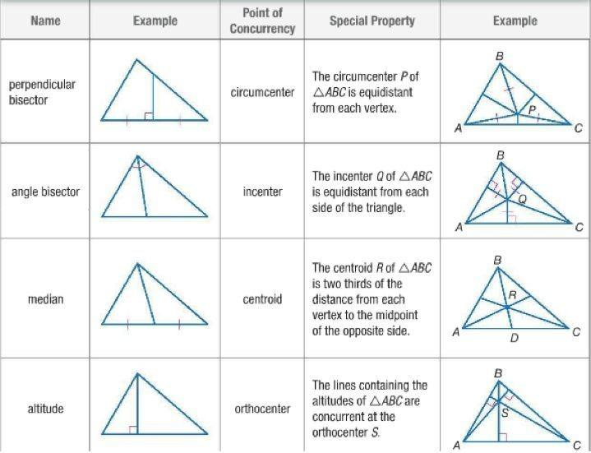
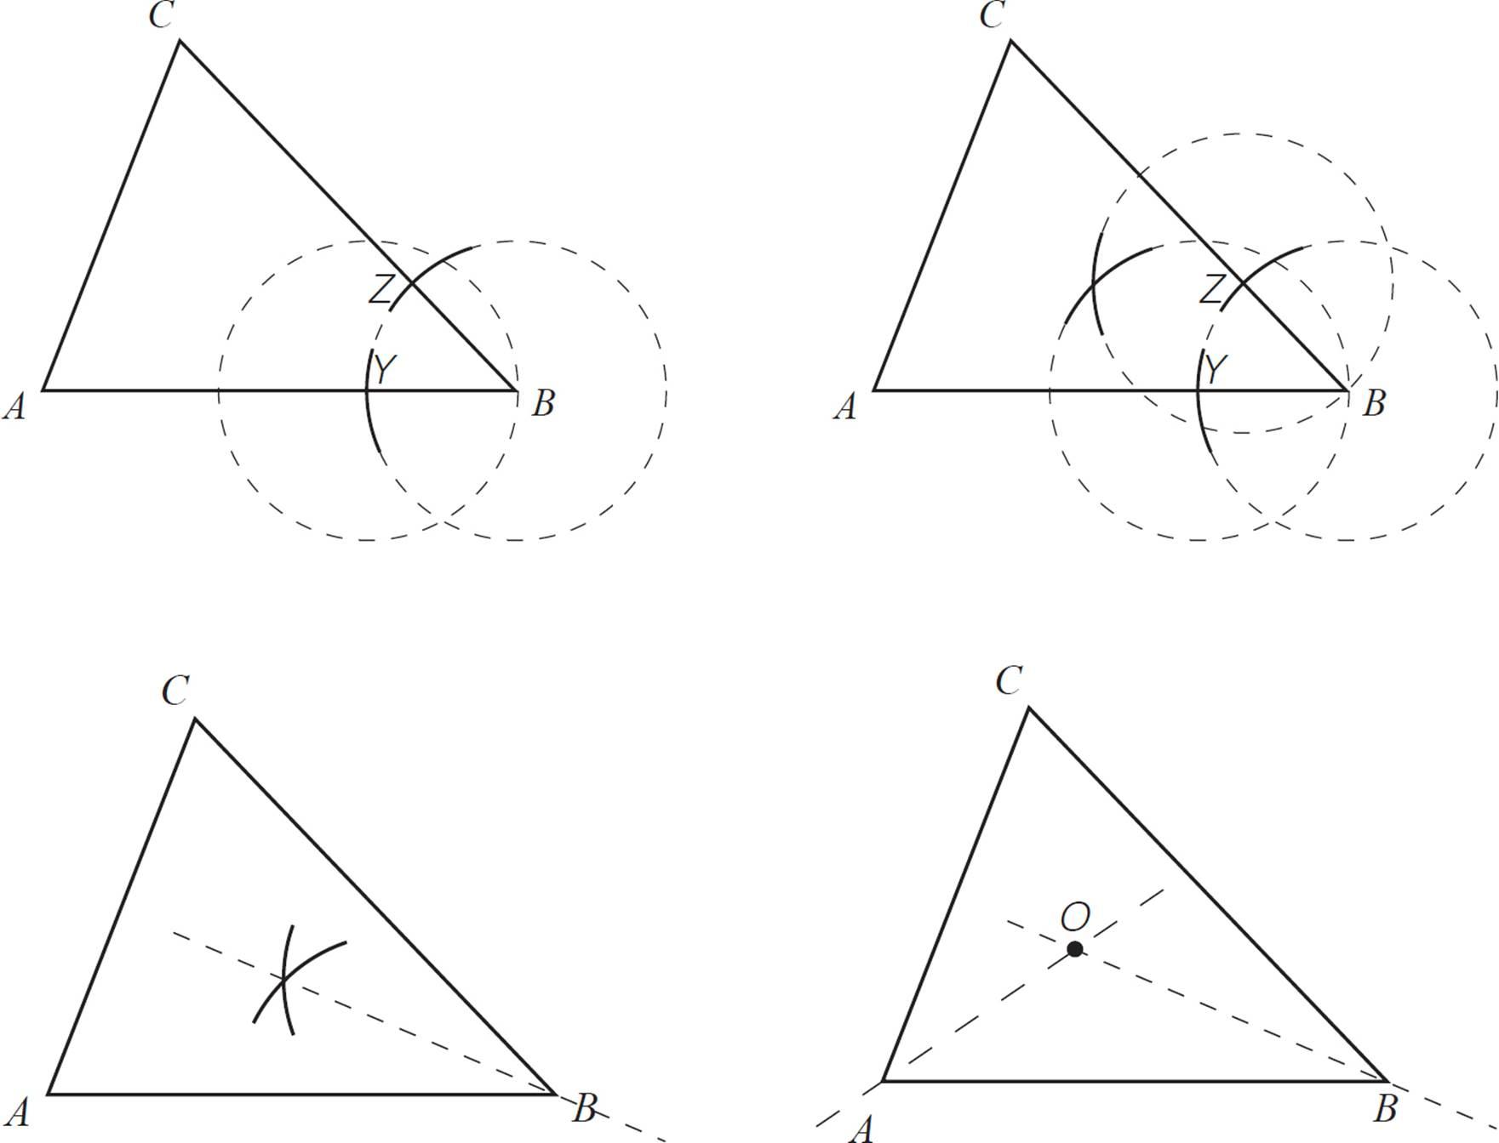
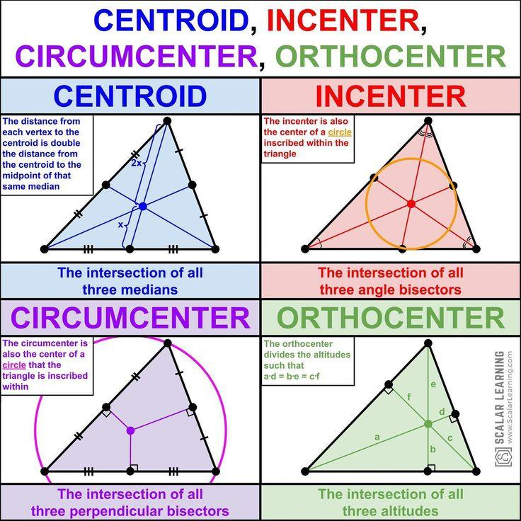
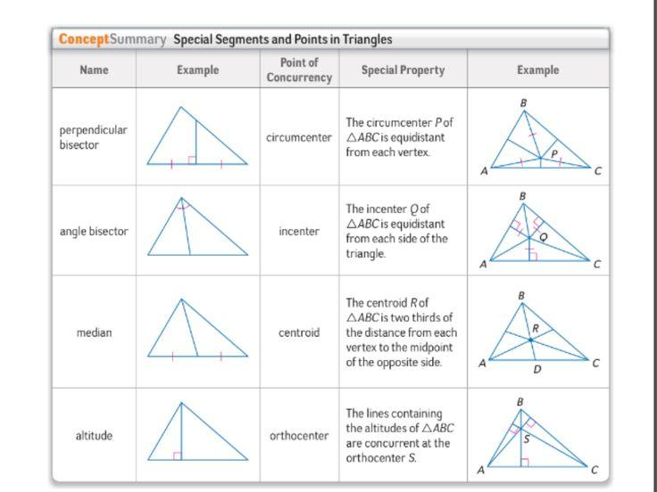

Auxiliary Construction for Congruence
# Source: AI Source: Provided by: [Data Path: Persons Table -> ID Column: 1, Name_En Column: Motasem Essam] -> From: [ChatGPT] on [7/25/2026]
A major purpose of an auxiliary construction is to make triangle congruence possible.
For example, suppose two triangles do not immediately satisfy an obvious congruence criterion.
Add an auxiliary segment.
Then you might obtain:
$$AB=DE, \\ BC=EF, \\ AC=DF.$$
Therefore:
$$\boxed{△ABC≅△DEF}$$
by SSS.
The auxiliary construction created the missing relationship needed for the proof.

Auxiliary Construction for Similarity
# Source: AI Source: Provided by: [Data Path: Persons Table -> ID Column: 1, Name_En Column: Motasem Essam] -> From: [ChatGPT] on [7/25/2026]
Similarly, an auxiliary parallel line can create similar triangles.
Given:
$$DE∥BC,$$
we can obtain:
$$∠ADE=∠ABC$$
and:
$$∠AED=∠ACB.$$
Therefore:
$$\boxed{△ADE∼△ABC}.$$
Then:
$$\boxed{\frac{AD}{AB}=\frac{AE}{AC}=\frac{DE}{BC}}$$
This is one of the most common uses of auxiliary constructions.

Auxiliary Construction for Area
# Source: AI Source: Provided by: [Data Path: Persons Table -> ID Column: 1, Name_En Column: Motasem Essam] -> From: [ChatGPT] on [7/25/2026]
Auxiliary lines can divide or rearrange a figure into simpler regions.
For example:
$$\text{Complex Figure}→\text{Rectangles + Triangles}$$
Then:
$$A_{\text{total}}=A_{1}+A_{2}+A_{3}.$$
A diagonal is often enough to divide a quadrilateral into two triangles:
$$\boxed{A_{ABCD}=A_{△ABC}+A_{△ACD}}$$
This is especially useful for area equality and area comparisons.
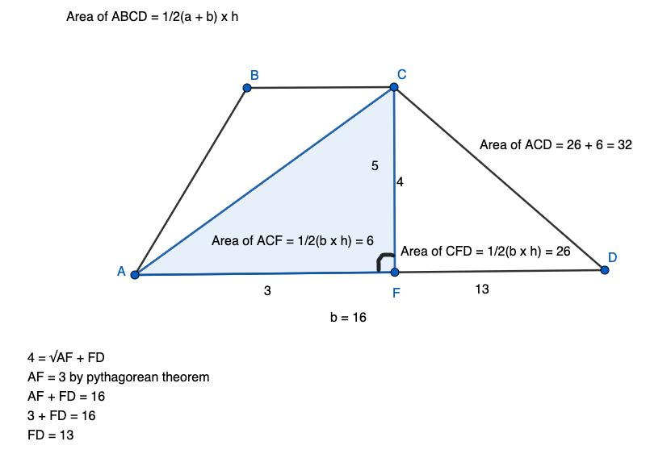
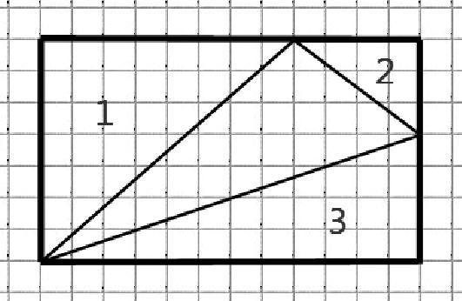
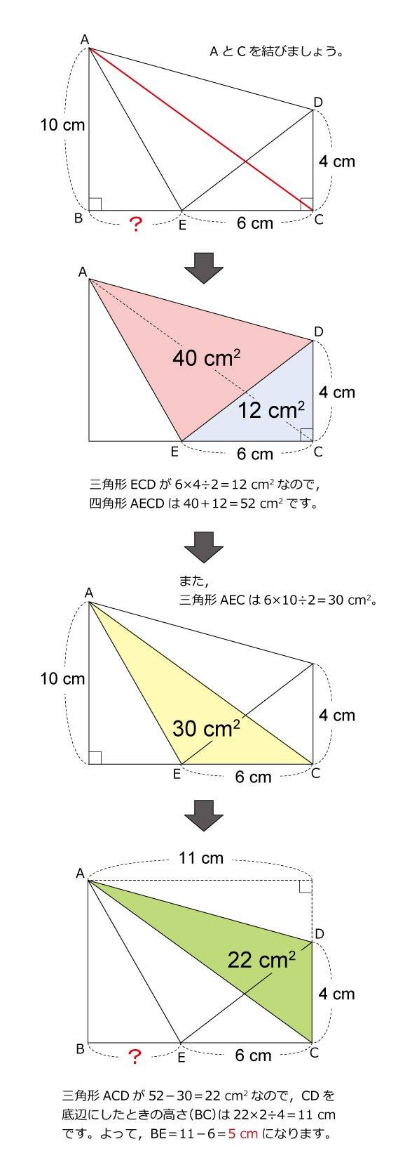

Auxiliary Construction for Circle Geometry
# Source: AI Source: Provided by: [Data Path: Persons Table -> ID Column: 1, Name_En Column: Motasem Essam] -> From: [ChatGPT] on [7/25/2026]
Auxiliary lines and circles are especially common in circle problems.
Possible constructions include:
- radius to a point of tangency,
- chord,
- diameter,
- secant,
- tangent,
- perpendicular radius,
- line joining centers,
- circle through selected points.
Example: Tangency
If $PT$is tangent to a circle with center $O$, construct radius $OT$.
Then:
$$\boxed{OT⊥PT}.$$
Therefore:
$$∠OTP={90}^{∘}.$$
This creates a right triangle and may allow the Pythagorean theorem to be used.
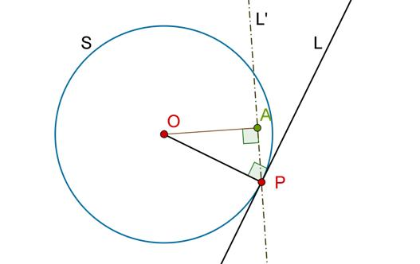
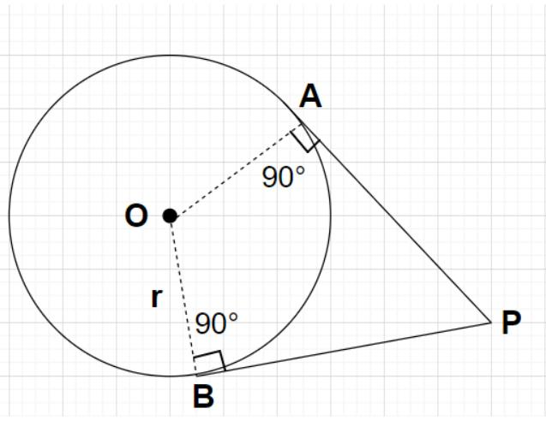
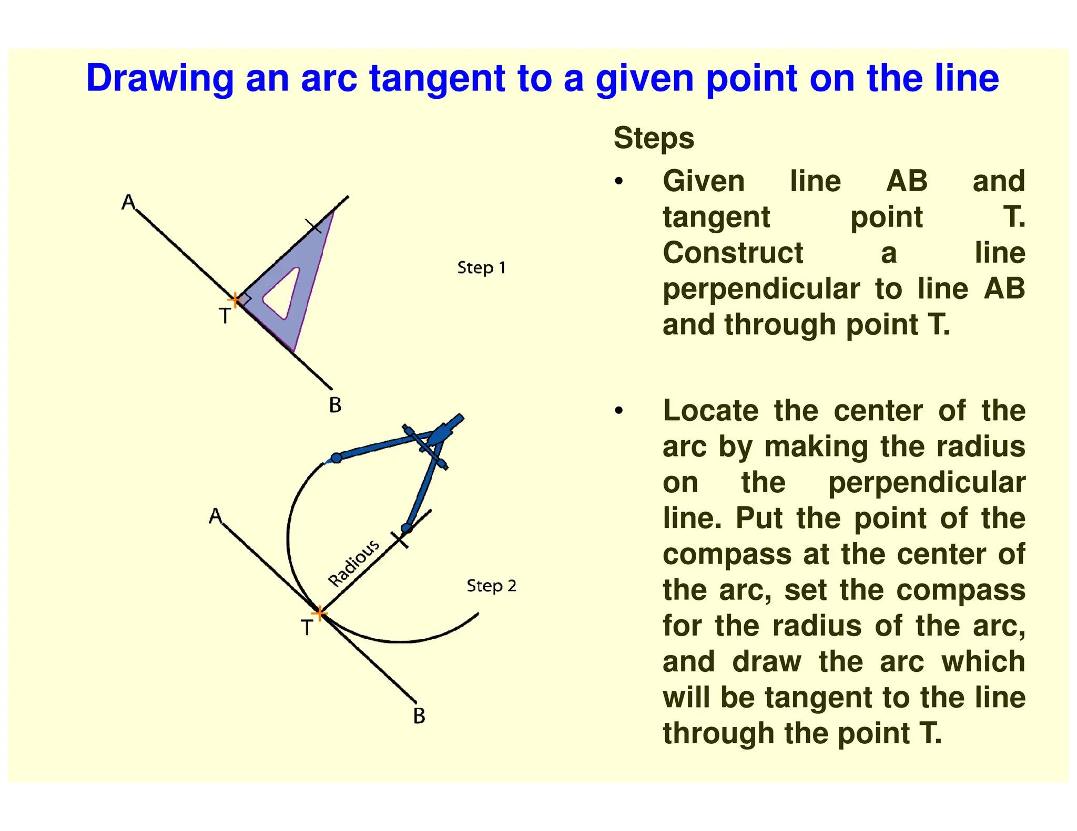
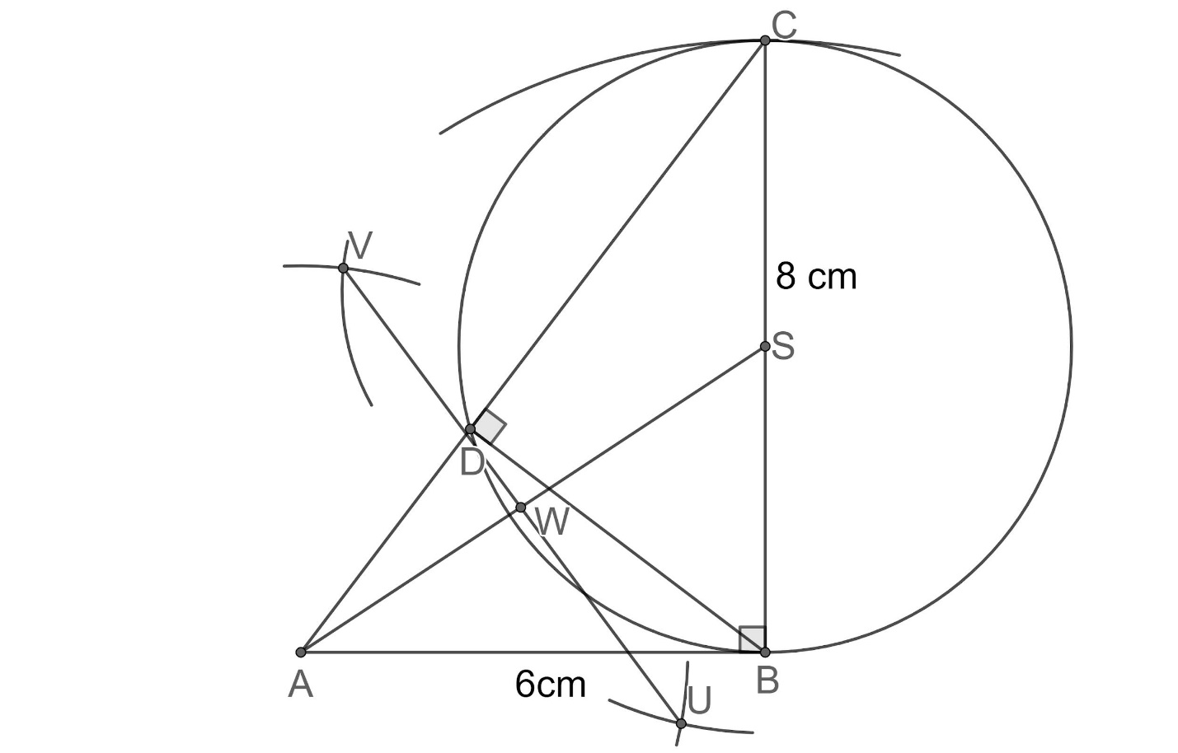
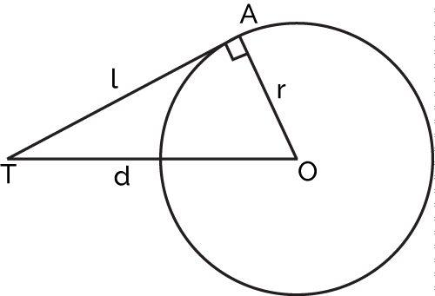
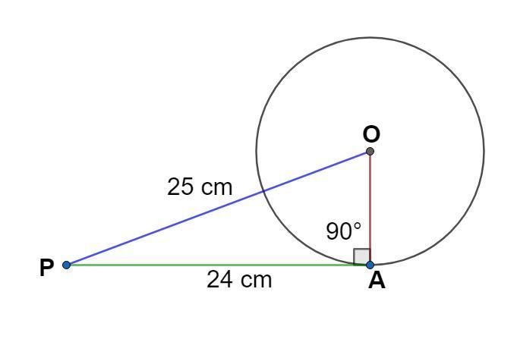

Auxiliary Construction for Symmetry
# Source: AI Source: Provided by: [Data Path: Persons Table -> ID Column: 1, Name_En Column: Motasem Essam] -> From: [ChatGPT] on [7/25/2026]
An auxiliary line can reveal symmetry.
For example, constructing a perpendicular bisector of $AB$identifies the axis of reflection symmetry between $A$and $B$.
If $P$lies on that line:
$$PA=PB.$$
Thus:
$$\boxed{\text{Symmetry}→\text{Equal Distances}}$$

Auxiliary Construction for Ratios
# Source: AI Source: Provided by: [Data Path: Persons Table -> ID Column: 1, Name_En Column: Motasem Essam] -> From: [ChatGPT] on [7/25/2026]
A parallel line or additional segment can create proportional relationships.
For example:
$$DE∥BC$$
produces:
$$\frac{AD}{DB}=\frac{AE}{EC}.$$
This is the type of relationship used in the Basic Proportionality Theorem.
Similarly, constructing cevians can prepare a triangle for the application of Ceva's Theorem.
Constructing a transversal can prepare a figure for Menelaus' Theorem.

Auxiliary Construction for Cevian Problems
# Source: AI Source: Provided by: [Data Path: Persons Table -> ID Column: 1, Name_En Column: Motasem Essam] -> From: [ChatGPT] on [7/25/2026]
In triangle geometry, a useful auxiliary construction may involve:
- a median,
- angle bisector,
- altitude,
- cevian,
- parallel line,
- perpendicular line.
For example, constructing a median creates:
$$BD=DC.$$
This equality can then be used with:
- congruence,
- area,
- Stewart's theorem,
- Apollonius' theorem.

Auxiliary Construction for Stewart's Theorem
# Source: AI Source: Provided by: [Data Path: Persons Table -> ID Column: 1, Name_En Column: Motasem Essam] -> From: [ChatGPT] on [7/25/2026]
Suppose a cevian $AD$is important.
The existing configuration already contains:
$$BD=m, DC=n, BC=a.$$
If necessary, auxiliary constructions can create right triangles or angle relationships that make the cevian easier to analyze.
Stewart's theorem then relates:
$$AB, AC, BD, DC, AD. \\ \boxed{b^{2}m+c^{2}n=a\left(d^{2}+mn\right)}$$
Thus an auxiliary construction may prepare a figure for a metric theorem.

Auxiliary Construction for Apollonius' Theorem
# Source: AI Source: Provided by: [Data Path: Persons Table -> ID Column: 1, Name_En Column: Motasem Essam] -> From: [ChatGPT] on [7/25/2026]
If $AD$is a median, then:
$$BD=DC.$$
An auxiliary construction can be used to expose the symmetry created by the median.
Apollonius' theorem gives:
$$\boxed{AB^{2}+AC^{2}=2\left(AD^{2}+BD^{2}\right)}$$
This is another example where a constructed or identified geometric element makes an important equality accessible.

Construction as Part of a Proof
# Source: AI Source: Provided by: [Data Path: Persons Table -> ID Column: 1, Name_En Column: Motasem Essam] -> From: [ChatGPT] on [7/25/2026]
An auxiliary construction can be inserted into a proof without changing the original givens.
The general structure is:
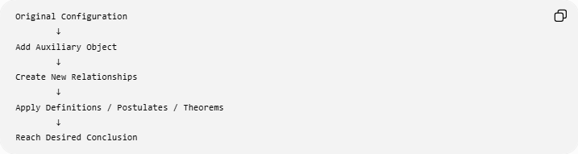
Original Configuration
↓
Add Auxiliary Object
↓
Create New Relationships
↓
Apply Definitions / Postulates / Theorems
↓
Reach Desired Conclusion
For example:
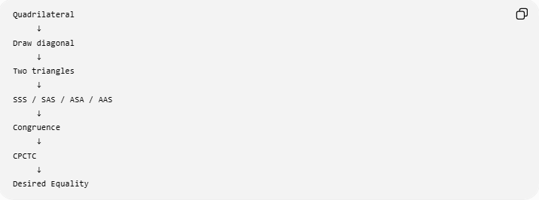
Quadrilateral
↓
Draw diagonal
↓
Two triangles
↓
SSS / SAS / ASA / AAS
↓
Congruence
↓
CPCTC
↓
Desired Equality

Auxiliary Construction Does Not Change the Original Figure
# Source: AI Source: Provided by: [Data Path: Persons Table -> ID Column: 1, Name_En Column: Motasem Essam] -> From: [ChatGPT] on [7/25/2026]
An auxiliary construction adds information to the diagram but does not change the original geometric objects or their given properties.
For example:
$$△ABC$$
remains:
$$△ABC$$
even after constructing an altitude $AD$.
The construction simply creates:
$$AD$$
and additional relationships.
Therefore:
$$\boxed{\text{Auxiliary Construction}=\text{Addition of a useful geometric object}}$$
not alteration of the original figure.

Auxiliary Construction vs Definition
# Source: AI Source: Provided by: [Data Path: Persons Table -> ID Column: 1, Name_En Column: Motasem Essam] -> From: [ChatGPT] on [7/25/2026]
These concepts should be distinguished.
Definition
States what a geometric object means.
Example:
A midpoint divides a segment into two equal parts.
Therefore:
$$AM=MB.$$
Auxiliary Construction
Adds an object to help solve a problem.
Example:
Construct the midpoint $M$of $AB$.
The construction creates the point $M$, while the definition explains the resulting relationship:
$$AM=MB.$$

Auxiliary Construction vs Theorem
# Source: AI Source: Provided by: [Data Path: Persons Table -> ID Column: 1, Name_En Column: Motasem Essam] -> From: [ChatGPT] on [7/25/2026]
A construction itself is not necessarily a theorem.
For example:
$$\boxed{\text{Construct perpendicular bisector}}$$
is a construction procedure.
Then the theorem can establish:
$$\boxed{PA=PB}.$$
So:
$$\boxed{\text{Construction}≠\text{Theorem}}$$
but:
$$\boxed{\text{Construction}→\text{Conditions for Theorem}→\text{Conclusion}}$$

Auxiliary Construction vs Geometric Equality
# Source: AI Source: Provided by: [Data Path: Persons Table -> ID Column: 1, Name_En Column: Motasem Essam] -> From: [ChatGPT] on [7/25/2026]
Auxiliary construction is a method, while geometric equality is a relationship.
For example:
$$\boxed{\text{Construct }AD}$$
is the construction.
Then:
$$\boxed{AB=AD}$$
could be the equality created by that construction.
Therefore:
$$\boxed{\text{Auxiliary Construction}→\text{Geometric Equality}}$$

Auxiliary Construction vs Construction of a Figure
# Source: AI Source: Provided by: [Data Path: Persons Table -> ID Column: 1, Name_En Column: Motasem Essam] -> From: [ChatGPT] on [7/25/2026]
There is an important distinction.
Construction of a figure
The goal is to construct the actual requested figure.
Example:
Construct a regular hexagon.
Auxiliary construction
The added object is constructed to help solve another problem.
Example:
Draw a diagonal inside the quadrilateral to prove two triangles are congruent.
Therefore:
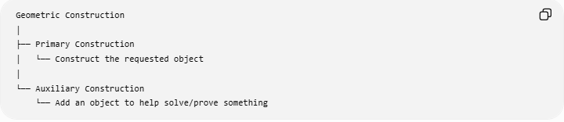
Geometric Construction
│
├── Primary Construction
│ └── Construct the requested object
│
└── Auxiliary Construction
└── Add an object to help solve/prove something

Common Auxiliary Constructions
# Source: AI Source: Provided by: [Data Path: Persons Table -> ID Column: 1, Name_En Column: Motasem Essam] -> From: [ChatGPT] on [7/25/2026]
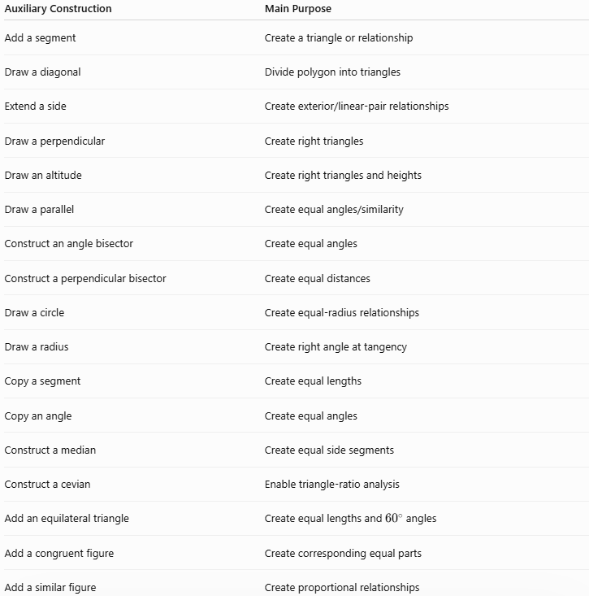
Auxiliary Construction | Main Purpose
Add a segment | Create a triangle or relationship
Draw a diagonal | Divide polygon into triangles
Extend a side | Create exterior/linear-pair relationships
Draw a perpendicular | Create right triangles
Draw an altitude | Create right triangles and heights
Draw a parallel | Create equal angles/similarity
Construct an angle bisector | Create equal angles
Construct a perpendicular bisector | Create equal distances
Draw a circle | Create equal-radius relationships
Draw a radius | Create right angle at tangency
Copy a segment | Create equal lengths
Copy an angle | Create equal angles
Construct a median | Create equal side segments
Construct a cevian | Enable triangle-ratio analysis
Add an equilateral triangle | Create equal lengths and ${60}^{∘}$angles
Add a congruent figure | Create corresponding equal parts
Add a similar figure | Create proportional relationships

Classification Summary
# Source: AI Source: Provided by: [Data Path: Persons Table -> ID Column: 1, Name_En Column: Motasem Essam] -> From: [ChatGPT] on [7/25/2026]
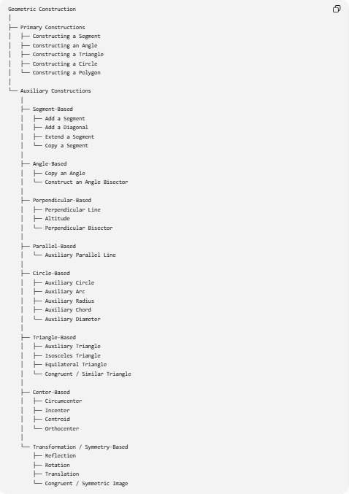
Geometric Construction
│
├── Primary Constructions
│ ├── Constructing a Segment
│ ├── Constructing an Angle
│ ├── Constructing a Triangle
│ ├── Constructing a Circle
│ └── Constructing a Polygon
│
└── Auxiliary Constructions
│
├── Segment-Based
│ ├── Add a Segment
│ ├── Add a Diagonal
│ ├── Extend a Segment
│ └── Copy a Segment
│
├── Angle-Based
│ ├── Copy an Angle
│ └── Construct an Angle Bisector
│
├── Perpendicular-Based
│ ├── Perpendicular Line
│ ├── Altitude
│ └── Perpendicular Bisector
│
├── Parallel-Based
│ └── Auxiliary Parallel Line
│
├── Circle-Based
│ ├── Auxiliary Circle
│ ├── Auxiliary Arc
│ ├── Auxiliary Radius
│ ├── Auxiliary Chord
│ └── Auxiliary Diameter
│
├── Triangle-Based
│ ├── Auxiliary Triangle
│ ├── Isosceles Triangle
│ ├── Equilateral Triangle
│ └── Congruent / Similar Triangle
│
├── Center-Based
│ ├── Circumcenter
│ ├── Incenter
│ ├── Centroid
│ └── Orthocenter
│
└── Transformation / Symmetry-Based
├── Reflection
├── Rotation
├── Translation
└── Congruent / Symmetric Image

Key Relationships Created by Auxiliary Constructions
# Source: AI Source: Provided by: [Data Path: Persons Table -> ID Column: 1, Name_En Column: Motasem Essam] -> From: [ChatGPT] on [7/25/2026]
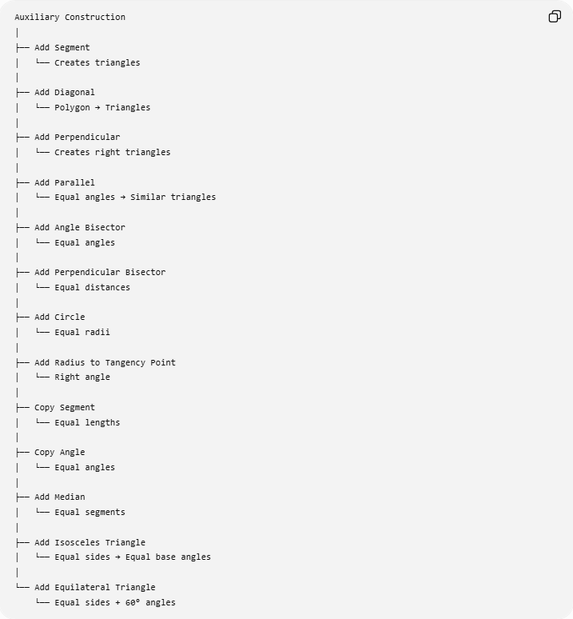
Auxiliary Construction
│
├── Add Segment
│ └── Creates triangles
│
├── Add Diagonal
│ └── Polygon → Triangles
│
├── Add Perpendicular
│ └── Creates right triangles
│
├── Add Parallel
│ └── Equal angles → Similar triangles
│
├── Add Angle Bisector
│ └── Equal angles
│
├── Add Perpendicular Bisector
│ └── Equal distances
│
├── Add Circle
│ └── Equal radii
│
├── Add Radius to Tangency Point
│ └── Right angle
│
├── Copy Segment
│ └── Equal lengths
│
├── Copy Angle
│ └── Equal angles
│
├── Add Median
│ └── Equal segments
│
├── Add Isosceles Triangle
│ └── Equal sides → Equal base angles
│
└── Add Equilateral Triangle
└── Equal sides + 60° angles

Important Principle
# Source: AI Source: Provided by: [Data Path: Persons Table -> ID Column: 1, Name_En Column: Motasem Essam] -> From: [ChatGPT] on [7/25/2026]
The best auxiliary construction is usually one that creates a known geometric structure.
For example:
$$\boxed{\text{Need Congruence}→\text{Construct a Segment}→\text{Create SSS/SAS/ASA/AAS}} \\ \boxed{\text{Need Similarity}→\text{Construct a Parallel}→\text{Create Equal Angles}} \\ \boxed{\text{Need Length}→\text{Construct Perpendicular}→\text{Create Right Triangle}→\text{Use Pythagorean Theorem}} \\ \boxed{\text{Need Equal Distances}→\text{Construct Perpendicular Bisector}→PA=PB} \\ \boxed{\text{Need Equal Angles}→\text{Construct Angle Bisector}→∠1=∠2}$$

Final Classification
# Source: AI Source: Provided by: [Data Path: Persons Table -> ID Column: 1, Name_En Column: Motasem Essam] -> From: [ChatGPT] on [7/25/2026]
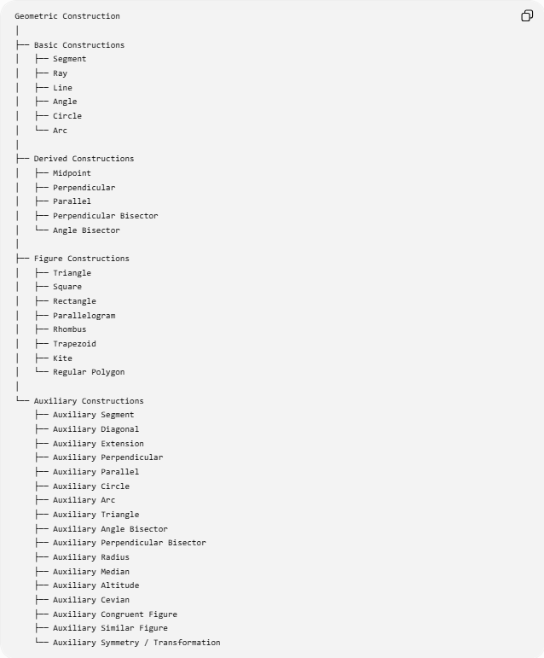
Geometric Construction
│
├── Basic Constructions
│ ├── Segment
│ ├── Ray
│ ├── Line
│ ├── Angle
│ ├── Circle
│ └── Arc
│
├── Derived Constructions
│ ├── Midpoint
│ ├── Perpendicular
│ ├── Parallel
│ ├── Perpendicular Bisector
│ └── Angle Bisector
│
├── Figure Constructions
│ ├── Triangle
│ ├── Square
│ ├── Rectangle
│ ├── Parallelogram
│ ├── Rhombus
│ ├── Trapezoid
│ ├── Kite
│ └── Regular Polygon
│
└── Auxiliary Constructions
├── Auxiliary Segment
├── Auxiliary Diagonal
├── Auxiliary Extension
├── Auxiliary Perpendicular
├── Auxiliary Parallel
├── Auxiliary Circle
├── Auxiliary Arc
├── Auxiliary Triangle
├── Auxiliary Angle Bisector
├── Auxiliary Perpendicular Bisector
├── Auxiliary Radius
├── Auxiliary Median
├── Auxiliary Altitude
├── Auxiliary Cevian
├── Auxiliary Congruent Figure
├── Auxiliary Similar Figure
└── Auxiliary Symmetry / Transformation

Conclusion
# Source: AI Source: Provided by: [Data Path: Persons Table -> ID Column: 1, Name_En Column: Motasem Essam] -> From: [ChatGPT] on [7/25/2026]
$$\boxed{\text{Auxiliary Construction}=\text{An additional geometric object constructed to help solve or prove a geometric problem}}$$
The central idea is:
$$\boxed{\text{Original Figure}→\text{Add Useful Object}→\text{Create Known Relationship}→\text{Apply Geometry}→\text{Conclusion}}$$
Auxiliary constructions are especially powerful because they can transform a difficult configuration into familiar structures such as triangles, right triangles, congruent triangles, similar triangles, circles, equal-angle configurations, equal-distance configurations, and proportional relationships.

